Attend or watch a Microsoft live event
You will have received an email from State Office with a Microsoft Teams Live Event link in it.
Before the day:
- You will have received an email from State Office with a Microsoft Teams Live Event link in it.
- Decide which device you will be joining the meeting from. If it’s a smart phone or tablet you will need to download the Teams app before the day.
- If its your PC you can just follow the below steps
--------------------------------------------------------------------------------------------------------------------------
On the day:
- Select the live event link in your email.

- You'll see different instructions based on how you join the event (like from the Teams app or watch on the web – just click the web option if you do not have the app installed).

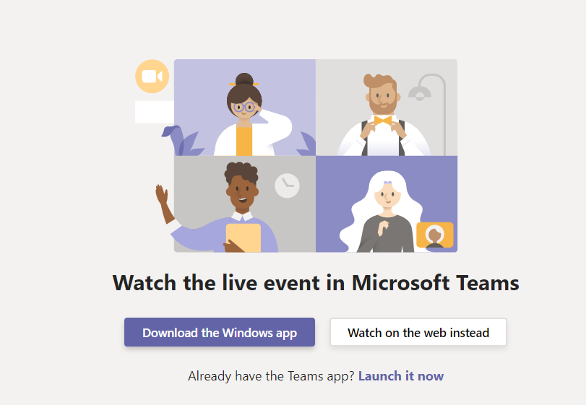

- Sign in using your Scouts NSW email address and password.
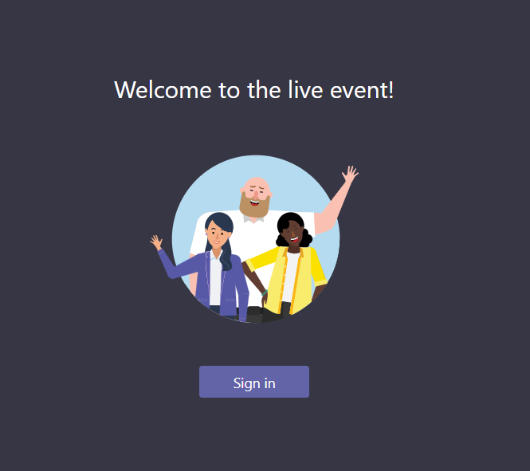
Optional Step - If you have not signed in on this device before using your Scouts NSW Email address it may ask you to verify who you are by sending a text message to your registered phone. You will then need to enter a code into your device.

- If the live event hasn't started, you'll see the message "The live event has not yet started." Just wait and it will start shortly.
- There are controls at the bottom of your screen to pause the action, adjust volume and the video quality.
- Once the event begins - If the video is jumping around or stopping/starting it is likely your internet connection is slow and unfortunately, we cannot assist with that.
----------------------------------------------------------------------------------------------------------------------
Participating in a live event
The Q&A panel only appears only if organizers have set it up. To ask a question:
- Select Q&A on the right side of the screen.
- Type your question in the compose box, and then select Send. If you want to ask your question anonymously, select Ask anonymously.
- In a Teams Live Event it is a presentation webinar – you cannot be seen on screen or heard.

