SCOUTS NSW - INCIDENT MANAGEMENT SYSTEM

ACCESSING FOLIO
FOLIO USER GUIDE
Version: 14 Feb 2020

- Anybody can submit an incident report however you must be a Folio User in order to perform the transactions described in this Folio user guide.
- Folio can be accessed by visiting https://scoutsnsw.foliogrc.com/d/users/sign_in from your internet browser.
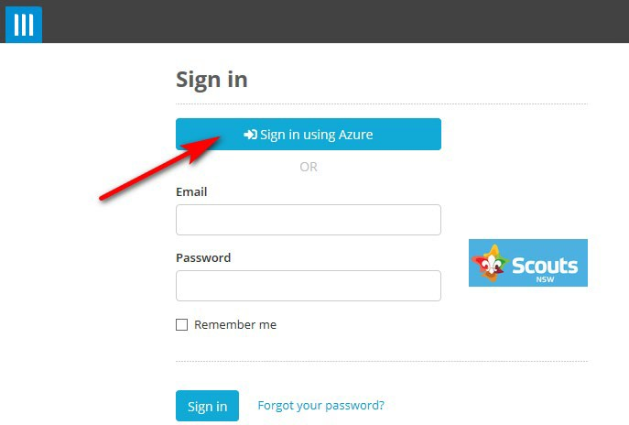

- Click on “Sign in using Azure” to use your Scouts NSW Office 365 account credentials.
- Alternatively, you can enter your email and password into the blank fields.

THE DASHBOARD

- The Dashboard is an overview of all incidents in the Folio system.
- You can access the dashboard from any screen by clicking on the Folio login (Blue Arrow)
- Actions needing your attention are listed under the “To Do List” (Red Arrow)
- You can customize the module location by clicking on the 4 pointed navigation arrow (Yellow Arrow) and dragging the module to the desired location.
- You can customize or remove unwanted modules by clicking on the icon with 3 dots (Green Arrow)
- The view below represents the most useful modules. All others can be removed.

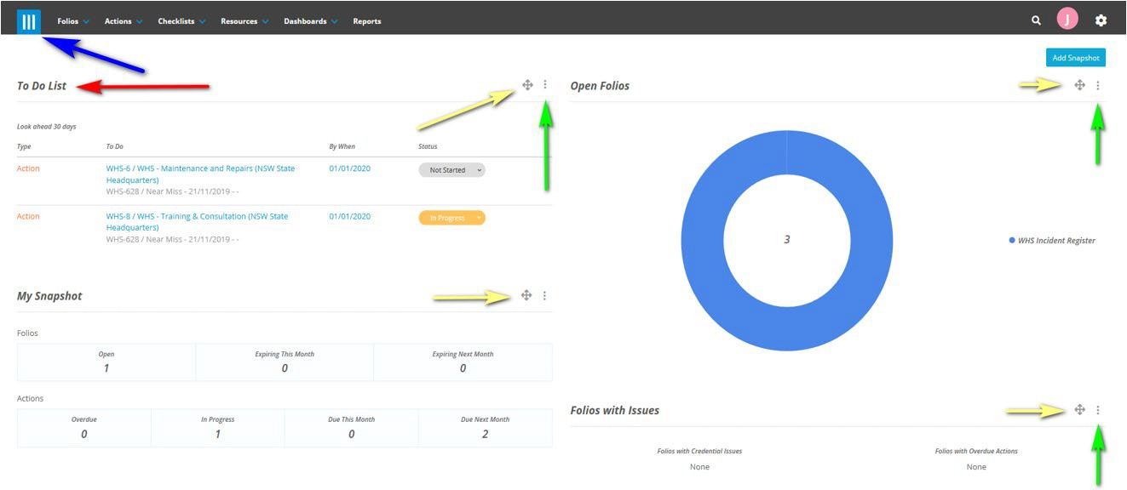

VIEWING OPEN WHS INCIDENTS

- For a view that displays all open incidents, click on “Folios” on the top banner followed by “WHS Incident Register”.
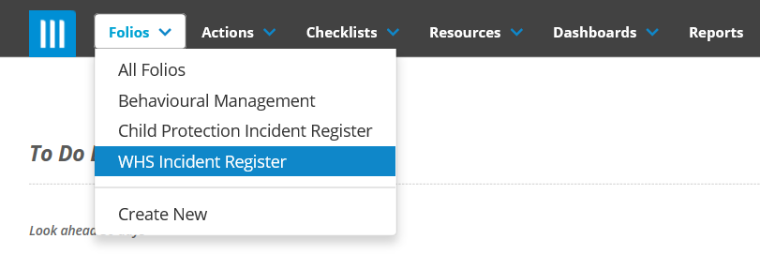
- The “WHS Incident Register” view will show all open incidents in a table. You can configure the columns displayed to match your preference by clicking on the icon with 3 dots (Red Arrow) and selecting “Configure Columns” in the menu that appears.

- 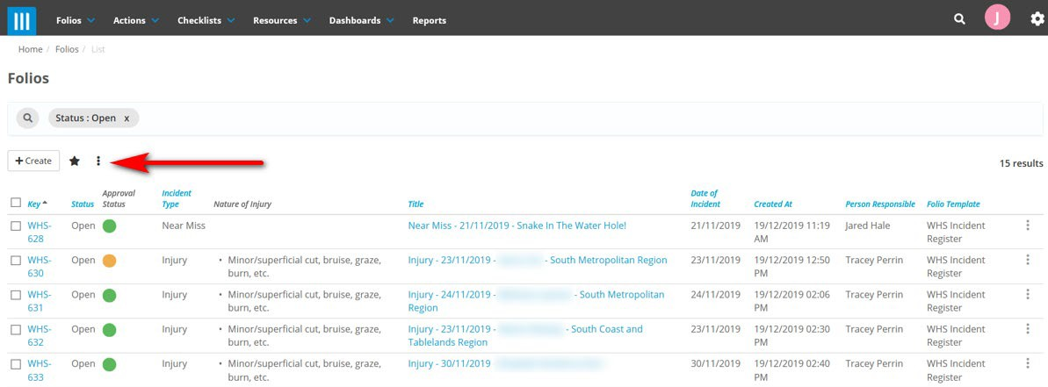
To view closed incidents - simply click on x in 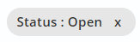 icon to reveal closed incidents.

POST INCIDENT REVIEW (including Investigation)
Introduction
- The purpose of the Post Incident Review is to record comments about how and why the incident occurred and what, if any, actions are needed to prevent reoccurrence. You might also want to make notes about the wellbeing of the person involved. In some cases, you can complete the post incident review based solely on the details provided in the report. For more significant incidents, you will need to liaise with the people involved in the incident or those managing the site, to investigate the incident and record improvement actions.
- If you are unsure about how to proceed with an investigation, seek advice from your Region Commissioner or the Risk team at State Office.
- You can conveniently email a copy of the incident report to somebody who does not have access to Folio, by following the steps under the CREATING a PDF section.

Completing a Post Incident Review

- When you are assigned a post incident review, you will receive an email notification. To view the incident report, do one of the following:
- Click on the link provided in the email to open to incident in Folio
OR:
- View the incident report from the list of open incidents (instructions provided in Section 3 VIEWING OPEN INCIDENTS)

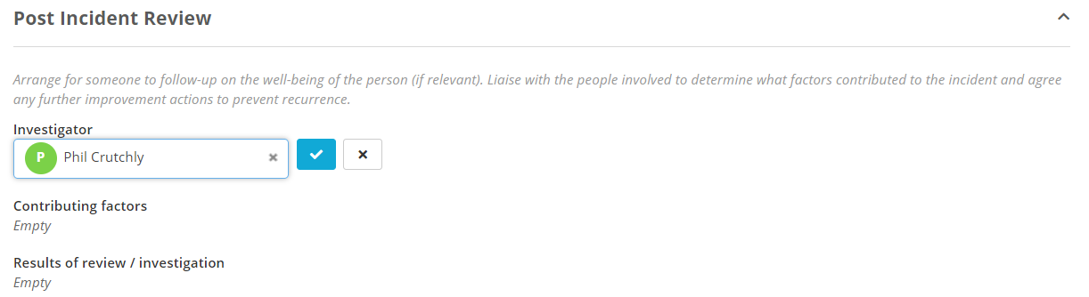

- View the incident report and familiarise yourself with the incident details.
- Scroll down to the Post Incident Review section at the bottom of the report.
- If you wish to reassign the task to another Folio user, follow the steps under the Reassigning Tasks Section
- You can complete the following sections now, or return at a later date when you have all the information you need. You can also add to your notes at any time you like. All information you enter is discoverable so keep to the facts and never write your personal opinions about anybody.

- Complete the Summary of contributing factors by ticking all items that apply. Select to save.
- Type your text in the Results of review / investigation field. Select to save.

- When you have completed the post incident review and you don’t plan to add any more, close the incident report. See instructions in the CLOSING an INCIDENT REPORT section.

CLOSING an INCIDENT REPORT

- Once you have completed the post incident review - close the incident report using the following steps:

- With the incident report open, click on the three dots at the top of the form (orange arrow) and then select close (green arrow).

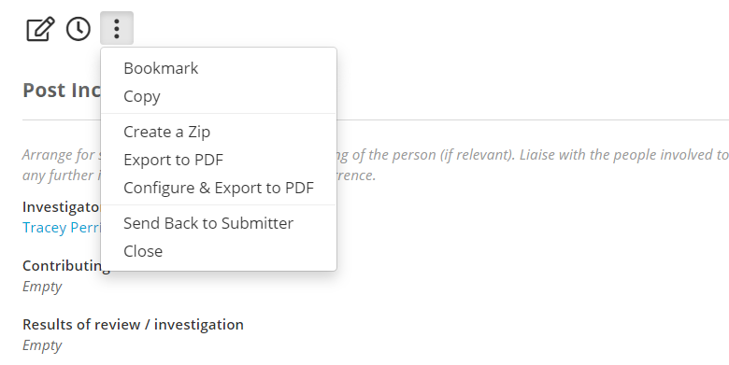

- A pop up box will appear. Click on Confirm (purple arrow).
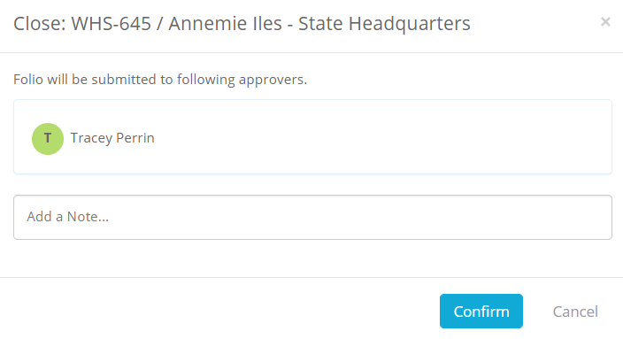

- Your request to close the incident report will be received by the Risk Team at State Office. The Risk team will get back to you if they have any questions.

CREATING a PDF doc
- If you need to provide a copy of the report to somebody who is not a Folio User, you can conveniently export to PDF using the following steps.
- With the incident report open, click on the three dots at the top of the form (orange arrow) and then select Configure and export to PDF (blue arrow). NOTE; As a matter of good practice, do not use ‘Export to PDF” because doing so will result in a pdf which includes all additional notes and results of the investigation (sharing these details is generally not ideal unless required).
- Ensure that only ‘DETAILS’ is ticked and then select “Export to pdf”

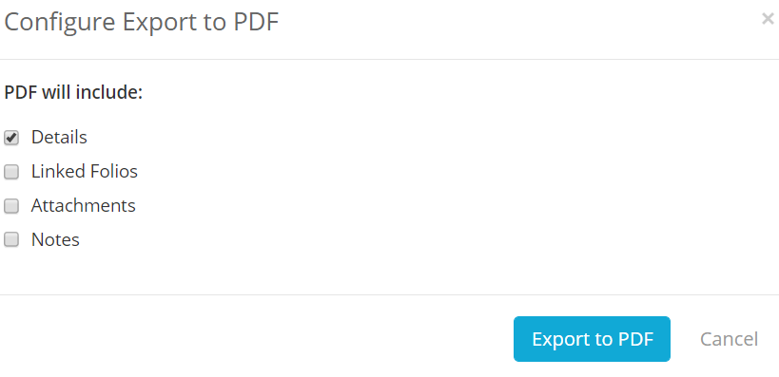
- After a second or two, the PDF doc will appear at the bottom of your screen. The PDF file can be then clicked and dragged into an email.
- Please limit the use of PDF to a need to know basis, as the data may be confidential and once sent in an email, you no longer have control where it goes.

DELEGATING the INVESTIGATION to another Folio user

- If you wish to delegate the investigation to another Folio User (for example when an RC wants assign an investigation to their Folio Delegate), you need to first include their name in the ‘PERSON RESPONISIBLE” so they can have access to view and edit the report.
- Go to the ‘PERSON RESPONISIBLE” field where your own name is currently. Click on the edit icon next to your name, and start typing the name of your delegate. When their name appears as an option, click on it to add their name as well as yours to the box. Select to save. (You may instead choose to remove your own name however you will no longer have the ability to edit the report. This option is entirely up to your personal preference).
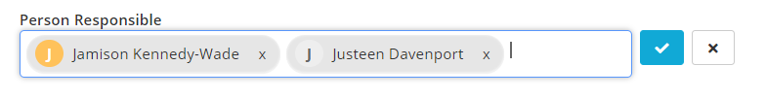

- To assign a name to the investigation, now go down to the INVESTIGATOR FIELD.
- Click on the edit icon and start typing the name of your delegate. When their name appears as an option, click on it to add their name to the box. Select to save. This field does NOT trigger any email notification – it only clarifies that you wish them to do the investigation. The previous step (Person Responsible) did notify them.
- Simply add the name of your intended Folio Delegate. Do NOT add your own name here unless you intend to look after the investigation.

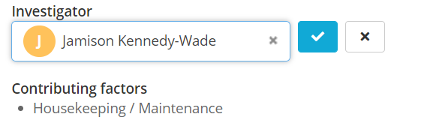

- Both you and your delegate will have access to the incident report, which means you can follow up with your delegate if necessary.
- Your delegate can now follow the instructions under POST INCIDENT REVIEW (including Investigation) and CLOSING an INCIDENT REPORT.
- Your delegate will now receive an email notification to let them know they have been assigned a Folio task.
- HINT: Always take care when delegating tasks in Folio. Double check you’ve selected the right person, before selecting . All Folio users are required to treat incidents be confidentially but in rare circumstances the information may be compromising if circulated to the wrong person.

EMAIL NOTIFICATIONS

- You will receive automated email notifications when:
  - You are assigned as Person Responsible
  - An incident you have requested to be closed, has been closed by the Risk Team
- RC’s will receive an email when an incident report has been triaged by the Risk Team at State office and assigned to their region.
- The RC of the assigned region will also receive the notification after triage even when they are not responsible for investigating (eg when the incident happens at a major and the major event organiser is assigned at the person responsible).

- Email notifications contain a direct link to the incident.

IF YOU NEED HELP

For assistance with gaining access to the system, please email IT on itsupport@nsw.scouts.com.au

For assistance with using the system or investigating incidents, please email Tracey Perrin on tracey.perrin@nsw.scouts.com.au or phone 9 735 9025

