Information for Region Office Managers
Online adult membership application form (A1)

All new adult members are required to complete the adult membership application form (A1). Scouts NSW has made this form available online via the Scouts NSW website.

Who needs to complete an adult membership application form (A1)?
All new adult member applicants who apply for membership with Scouts NSW must complete an online A1 form.

Why is the form now online?
Scouts NSW has made this form available online to simplify the process for adult members to join Scouts NSW. The online A1 form also streamlines the endorsement process for Region Office Managers (ROM) and eliminates the need for a paper-based form by integrating directly into ScoutLink.

The content of the A1 form has not changed.

Where is the online A1 form located?
The online A1 form can be accessed from the Scouts NSW website - https://www.nsw.scouts.com.au/adult-membership-application/

Is the paper based A1 still available and accepted?
Paper-based forms are still available for now but will be withdrawn from availability in January 2020. Therefore, we recommend you begin using the online version of the A1 form as soon as possible. Paper-based forms will continue to be accepted and processed until 1 February 2020. After this time, all A1 applications will need to be completed using the online forms.

In some exceptionally rare circumstances, an applicant may need to access a paper-based A1 form after this date. In such cases, permission will be required from the Region Commissioner/District Commissioner and the paper form will be supplied and processed by the ROM.

What is the process for online A1 applications?
The process for the online adult membership application form as at 21 October 2019 is detailed below:

Step 1 | The adult member applicant completes the online A1 form.
Step 2 | The Region Office Manager (ROM), Region Commissioner (RC) or District Commissioner (DC), and Group Leader (GL) or Leader in Charge (LIC) receive an email advising an application is waiting to be endorsed in ScoutLink by the GL/LIC.
Step 3 | The Group Leader conducts two mandatory reference checks and an introductory interview with the adult member applicant. The GL/LIC must then log into ScoutLink to endorse the application.
Step 4 | The RC/DC receives an email advising there is an endorsed application in ScoutLink that is awaiting their approval. The RC/DC must then log into ScoutLink and approve or reject the application endorsement.
Step 5 | The ROM will receive an email confirming that the endorsement has been approved, and will then need to log into ScoutLink and validate the applicant’s Working With Children Check (WWCC).
Step 6 | The State Office receives an email advising that a Police Check is required. The State Office representative must log into ScoutLink to verify the Police Check. The adult member can now participate in Scout activities.

Note: If the WWCC or Police Check is not approved, the ROM or State Office must advise the Child Protection Team, which will determine whether the application can proceed. In many cases, the application will be allowed to continue. If applicants are resigned, an email will be sent to the RC/DC to advise them of this, and the application will not progress any further. In this case, the adult helper will not be allowed to participate in Scout activities.

What are my responsibilities as a Region Office Manager?
As a Region Office Manager, it is your responsibility to:
- Monitor your emails for any new adult membership (A1) applications.
- Validate the applicant’s Working With Children Check (WWCC), then log into ScoutLink to confirm this has been done.
- Be alert to notifications from Group Leaders/Leaders in Charge if there are any issues with an application.

What will the email notification look like?
The email notification will look like the message below:
How do I confirm that a WWCC has been satisfactorily completed in ScoutLink?
- Log into ScoutLink at https://scoutlink.nswscouts.com.au
- Click on the ScoutLink context menu on the left-hand side to expand further options
- Click on Member menu item
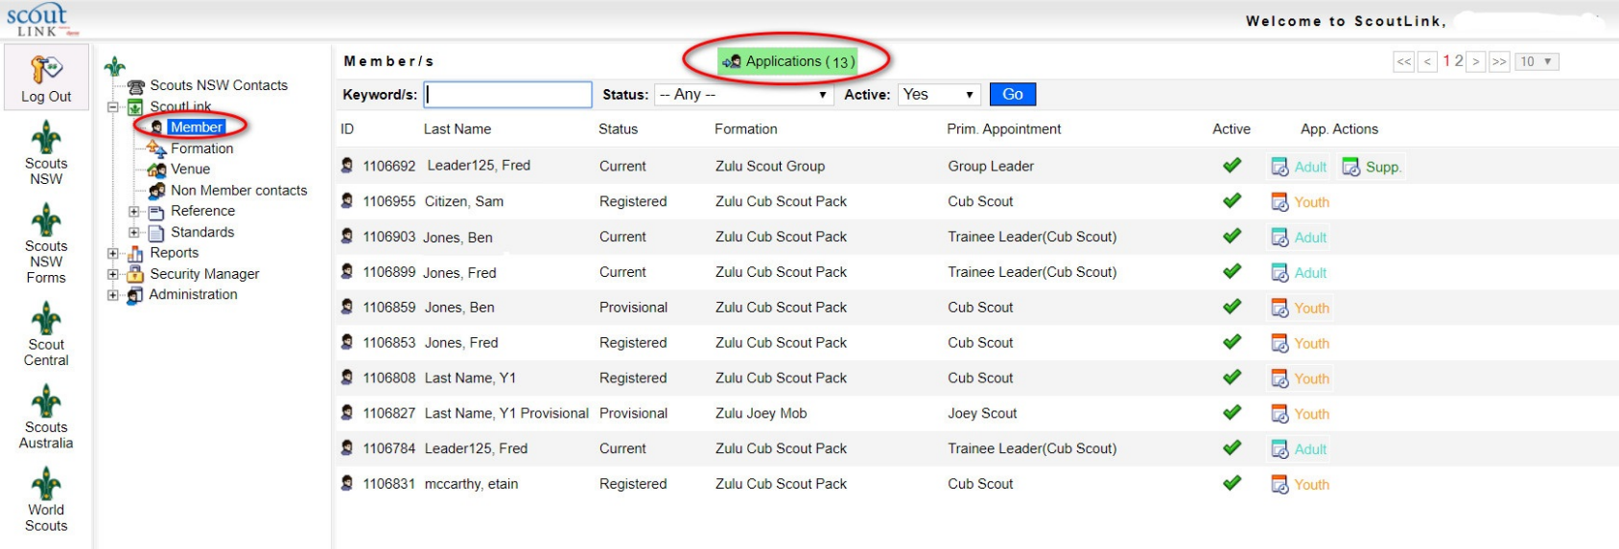
- Click on the green Applications button

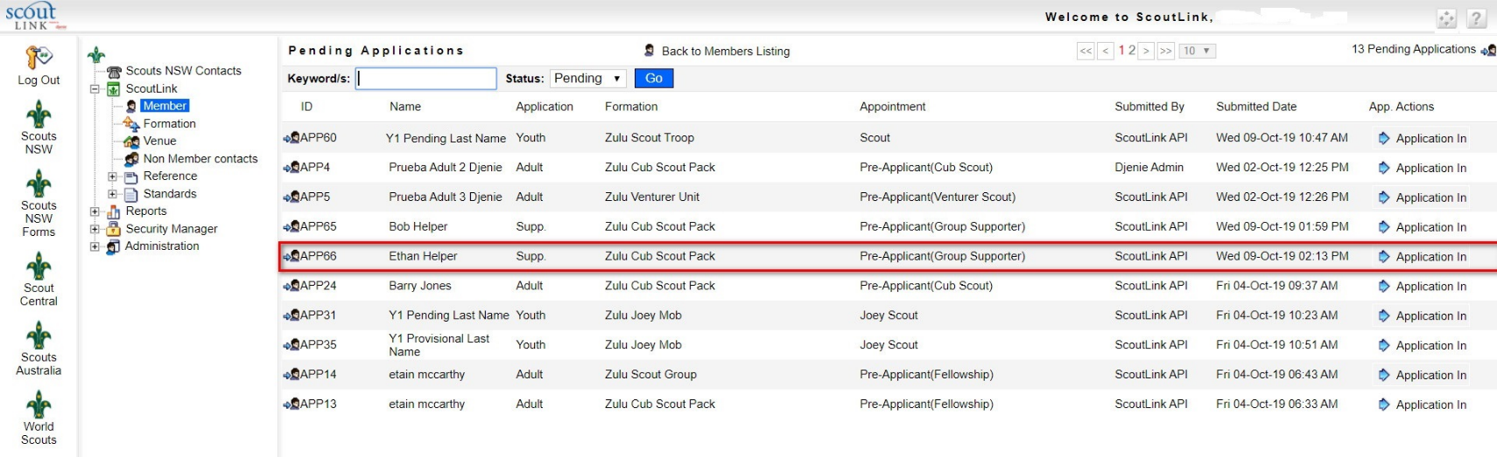
5. Click on the Application In button on the applicant you wish to process

6. Click on the WWCC tab.
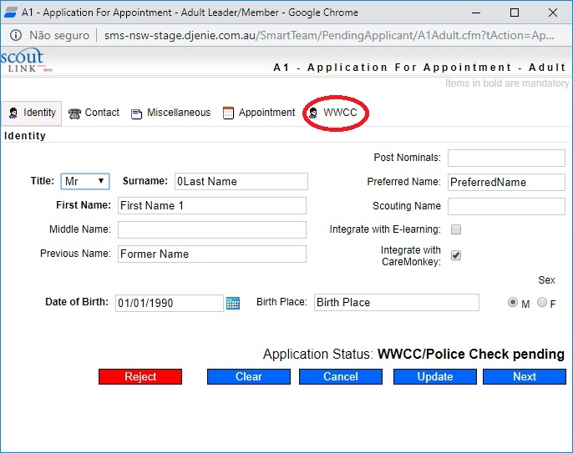

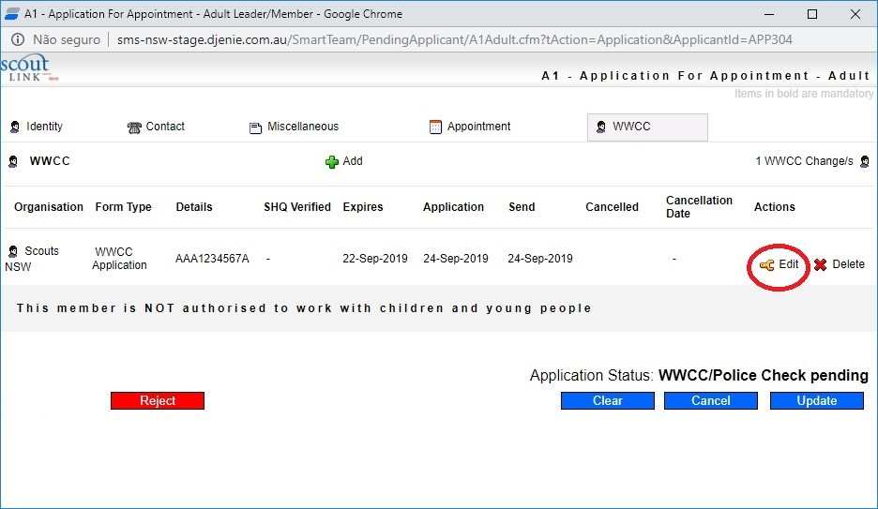
7. Then click on the Edit icon next to the WWCC Application number

8. For a WWCC that has been APPROVED, choose the WWCC Confirmation option under the Form Type field

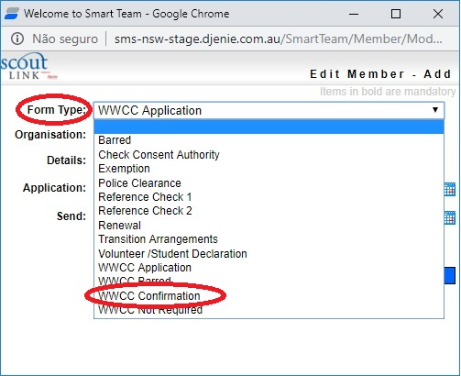

9. For a WWCC that has been REJECTED, choose the WWCC Barred option under the Form Type field

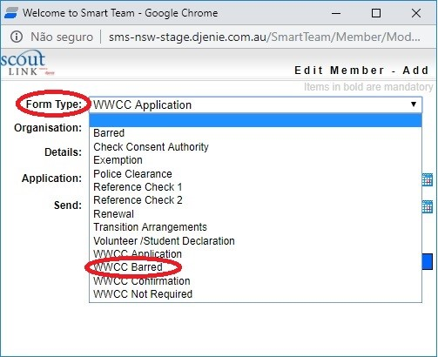

10. Enter the Scouts HQ verification date next to the SHQ Verified field
11. Click on the Edit button to save your changes

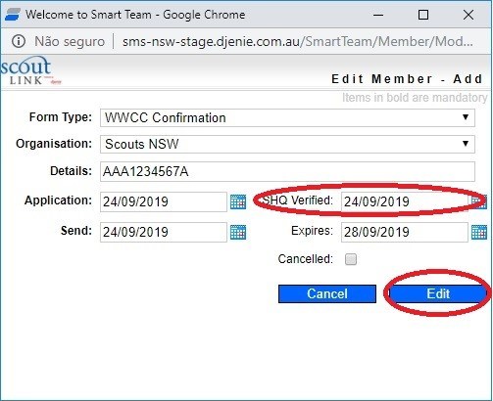

12. For a FAILED WWCC, click the Reject button.
13. For a SUCCESSFUL WWCC, click the Update button.
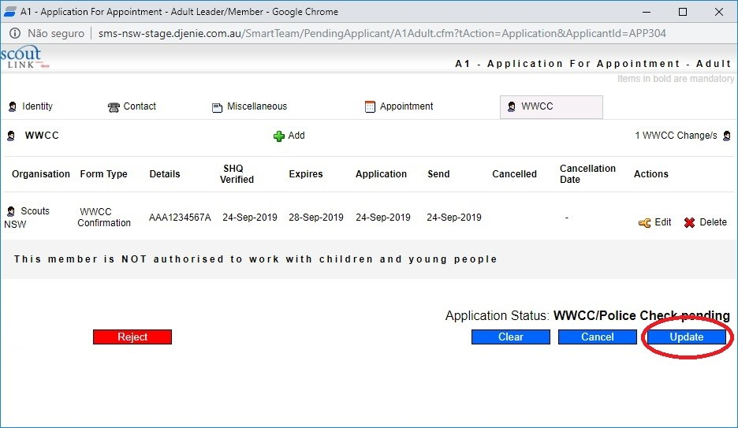

14. The applicant will still be listed as a Pre-Applicant in the Pending Applications list. An email will now be sent to the State Office to advise them that they need to log into ScoutLink to confirm the Police Check has been satisfactorily completed for this applicant.

Whom can I contact if I have a question about the A1 form?
For user questions, please contact Member Services at info@nsw.scouts.com.au. If you experience technical issues with the form, please contact the IT department at ITSupport@nsw.scouts.com.au

