Information for Group Leaders/Leaders in Charge
Online adult membership application form (A1)

All new adult members are required to complete the adult membership application form (A1). Scouts NSW has made this form available online via the Scouts NSW website.

Who needs to complete an adult membership application form (A1)?
All new adult member applicants who apply for membership with Scouts NSW must complete an online A1 form.

Why is the form now online?
Scouts NSW has made this form available online to simplify the process for adult members to join Scouts NSW. The online A1 form also streamlines the endorsement process for Group Leaders/Leaders in Charge and Regions, and eliminates the need for a paper-based form by integrating directly into ScoutLink.

The content of the A1 form has not changed.

Where is the online A1 form located?
The online A1 form can be accessed from the Scouts NSW website - https://www.nsw.scouts.com.au/adult-membership-application/

Is the paper based A1 still available and accepted?
Paper-based forms are still available for now but will be withdrawn from availability in January 2020. Therefore, we recommend you begin using the online version of the A1 form as soon as possible. Paper-based forms will continue to be accepted and processed until 1 February 2020. After this time, all A1 applications will need to be completed using the online forms.

In some exceptionally rare circumstances, an applicant may need to access a paper-based A1 form after this date. In such cases, permission will be required from your Region Commissioner/District Commissioner and the paper form will be supplied and processed by the Region Office Manager.

What is the process for online A1 applications?
The process for the online adult membership application form as at 21 October 2019 is detailed below:

Step 1 | The adult member applicant completes the online A1 form and the details are automatically entered into ScoutLink.
Step 2 | The Region Office Manager (ROM), Region Commissioner (RC) or District Commissioner (DC), and Group Leader (GL) or Leader in Charge (LIC) receive an email advising an application is waiting to be endorsed in ScoutLink by the GL/LIC.
Step 3 | The Group Leader conducts two mandatory reference checks and an introductory interview with the adult member applicant. The GL/LIC must then log into ScoutLink to endorse the application.
Step 4 | The RC/DC receives an email advising there is an endorsed application in ScoutLink that is awaiting their approval. The RC/DC must then log into ScoutLink and approve or reject the application endorsement.
Step 5 | The ROM will receive an email confirming that the endorsement has been approved, and will then need to log into ScoutLink and validate the applicant’s Working With Children Check (WWCC).
Step 6 | The State Office receives an email advising that a Police Check is required. The State Office representative must log into ScoutLink to verify the Police Check. The adult member can now participate in Scout activities.

Note: If the WWCC or Police Check is not approved, the ROM or State Office must advise the Child Protection Team, which will determine whether the application can proceed. In many cases, the application will be allowed to continue. If applicants are resigned, an email will be sent to the RC/DC to advise them of this, and the application will not progress any further. In this case, the adult helper will not be allowed to participate in Scout activities.

What are my responsibilities as a Group Leader/Leader in Charge?
As a Group Leader/Leader in Charge, it is your responsibility to:
- Monitor your emails for any new adult membership (A1) applications.
- Complete an initial review of each application, then conduct the mandatory reference checks and the introductory interview with the adult member applicant before logging into ScoutLink to endorse their application.
- Notify your Region Office if there are any issues with an application.

Now that the A1 application form is available online, where can I submit the reference check document?
Group Leaders/Leaders in Charge will receive an email informing them that an online A1 application has been made and is waiting for their endorsement in ScoutLink. The same email will include a link to a reference check document that should be used to record the details of each reference check.

The reference check includes the following questions:
- How long have you known the applicant and in what capacity?
- How do you think they would cope with acting as a leader in a recreational learning environment?
- How does the applicant interact with young people and adults?
- How does the applicant deal with stressful situations and conflict? What is your view of their temperament?
- How would you say that the applicant would work with a team? Are they honest and trustworthy?
- How would you describe the applicant’s manner with young people? Is there anything which in your view makes them unsuitable to work with young people?
- Is there anything else you would like to highlight? Any additional comments?
- Date reference check conducted.

A series of free text paragraph fields are included in the online Group Leader/Leader in Charge endorsement form for the Group Leader/Leader in Charge to record these answers. (See Appendix 1.)

Note: Please ensure you have the answers for both reference checks before completing the online form. It is not possible to save the answers for one reference check and then go back and complete the form when you have done the second reference check. Therefore, you’ll need to enter both reference checks at the same time.

When does the introductory interview take place?
The introductory interview with the adult member applicant should take place after your initial review of their application, and after the mandatory reference checks have been conducted. When endorsing the application in ScoutLink, you’ll be asked to confirm that the introductory interview with the adult member applicant has taken place.

What will the email notification look like?
The email notification will look like the message below:

How do I endorse an application for adult membership in ScoutLink?
- Log into ScoutLink at https://scoutlink.nswscouts.com.au
- Click on the ScoutLink context menu on the left-hand side to expand further options
- Click on Member menu item
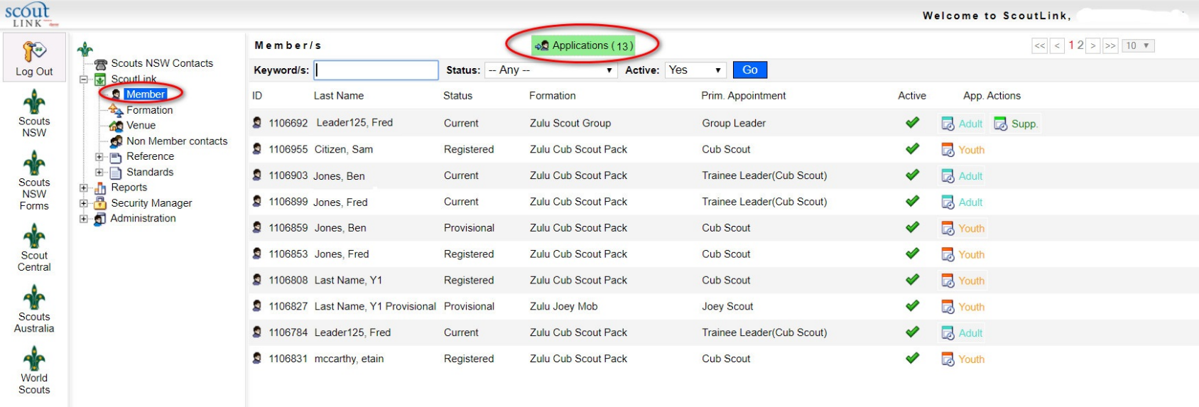
- Click on the green Applications button

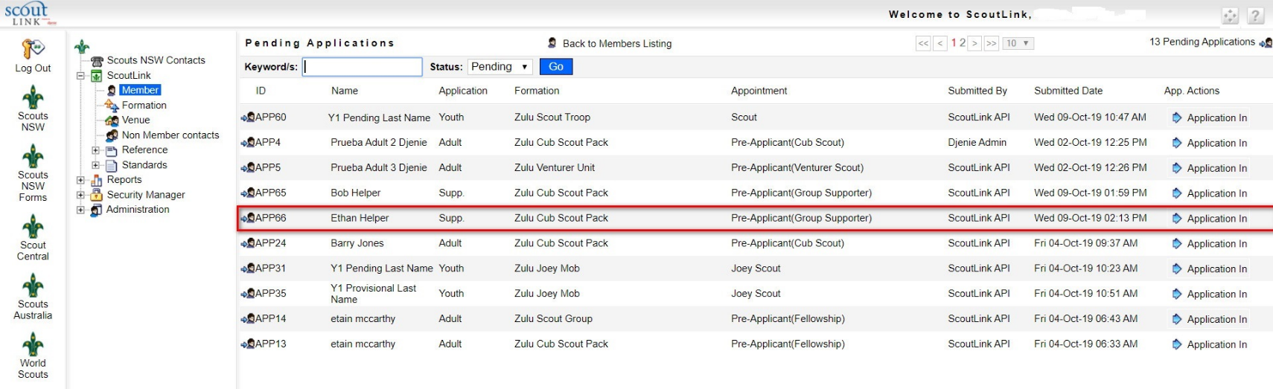
5. Click on the Application In button on the applicant you wish to process

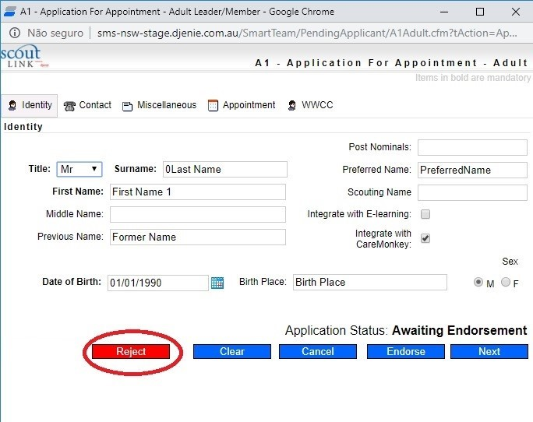
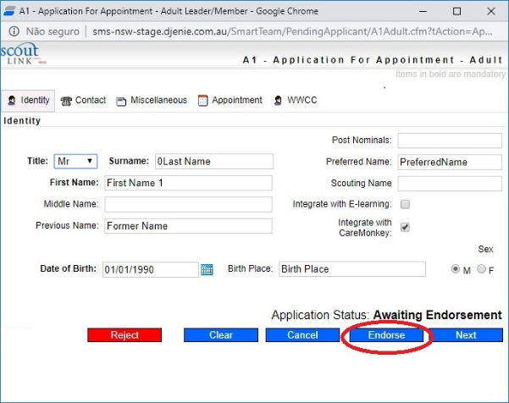
6. Click the Reject button to refuse the application or Endorse to approve the application

7. The applicant will still be listed as a Pre-Applicant in the Pending Applications list. An email will now be sent to the RC to advise them that they need to log into ScoutLink to approve or reject this endorsement.

Whom can I contact if I have a question about the A1 form?
For user questions, please contact Member Services at info@nsw.scouts.com.au. If you experience technical issues with the form, please contact the IT department at ITSupport@nsw.scouts.com.au

Appendix 1

