Forms Automation
New Adult Process
V2

Contents
1 Version tracker 2
2 Main changes 4
3 Process overview 4
4 Accept or reject an application 5
5 Endorse the formation approval 10
6 Updating the Working with Children Check (WWCC) 15
7 Updating the Police Check 22

Version tracker

Date | Version No# | Update Type | Author | Comments
22/09/2019 | 1.0 | Draft | Alexandre De Silva | First draft
1/10/2019 | 1.1 | Minor | Jared Hale | Process overhaul
2/10/2019 | 2.0 | Major | Jared Hale | Manual redesign, information and additional screenshots added
10/10/2019 | 2.1 | Minor | Jared Hale | Review, screenshot cleanup
16/10/2019 | 2.2 | Minor | Sam Lenton | Proofing and minor process updates, revised screenshots added

Main changes

- New applicants are now automatically registered on ScoutLink.
- Group Leaders will be required to go to ScoutLink to approve the application.
- A CareMonkey account will be automatically created and linked.
- Region Office Manager will be required to go to ScoutLink to validate the applicant’s Working With Children Check (WWCC)
- State Office will be required to complete the applicant’s Police Check.
- Periodic reminder emails will be sent when there are any pending applications that require action.

Process overview
This process allows new prospective members to be automatically registered on ScoutLink without human intervention. This eliminates the need for paper forms and manual data entry of application information by the Group Leaders or Region Office Managers (ROM).

Further time is saved by automating the CareMonkey account creation process to track medical conditions, parental consent and other external services.

If the Region Office Manager receives an email that was supposed to go to the Group Leader or to the Region Commissioner, it means that there is no Group Leader or Region Commissioner for the Group.

Accept or reject an application

- Log into ScoutLink at https://scoutlink.nswscouts.com.au
- Click on the “ScoutLink” context menu on the left-hand side to expand further options

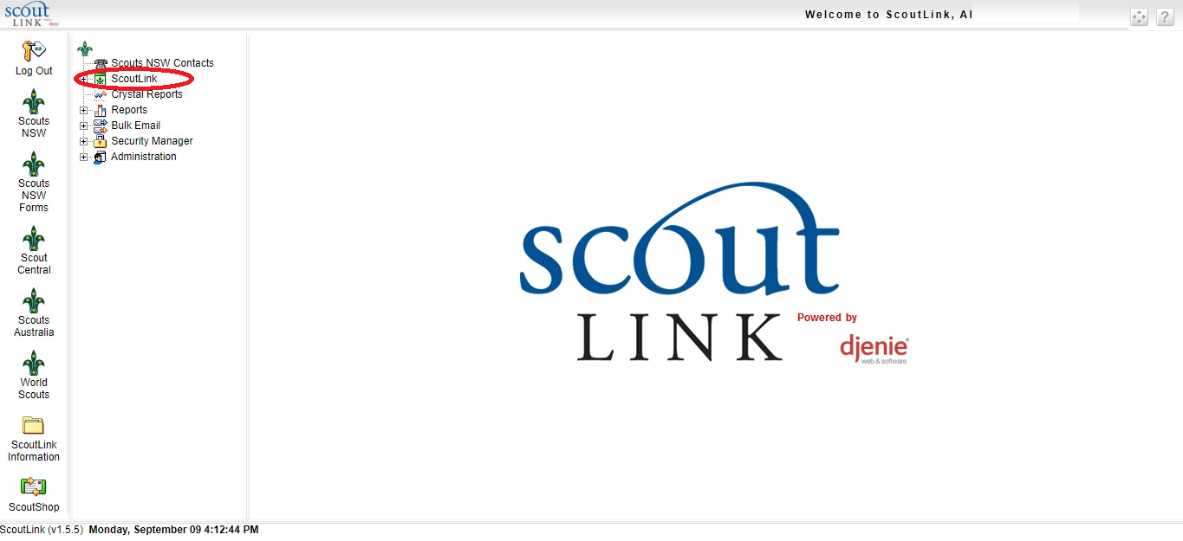

- Click on “Member” menu item.
- Click on the “Pending Applications” button highlighted in green.
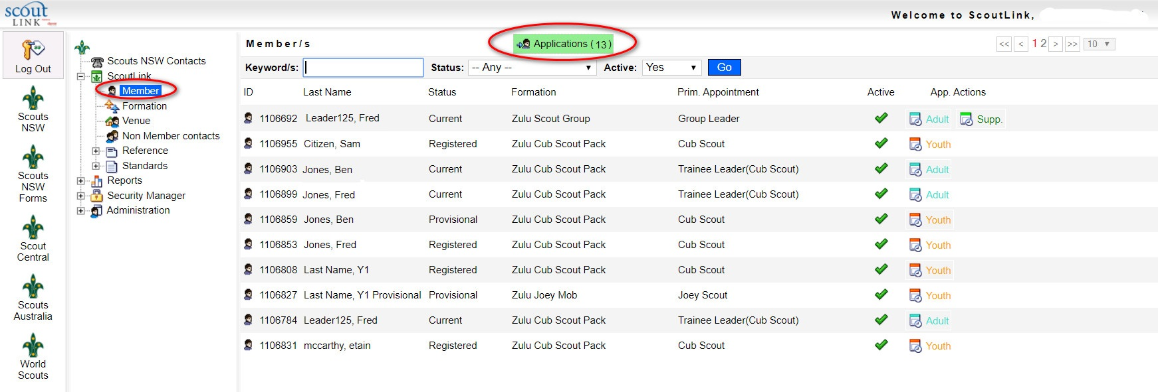

- Click on the “Application In” button on the applicant you wish to process

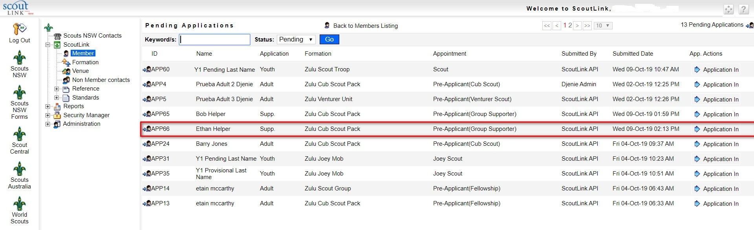

- Click on the “Reject” button to refuse the application or “Endorse” to approve the application

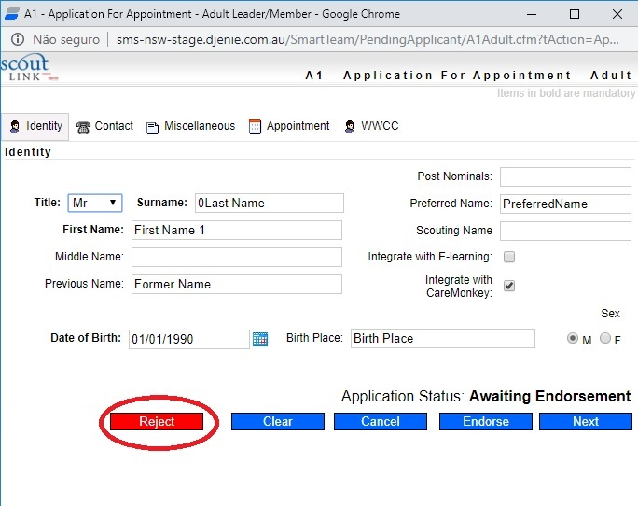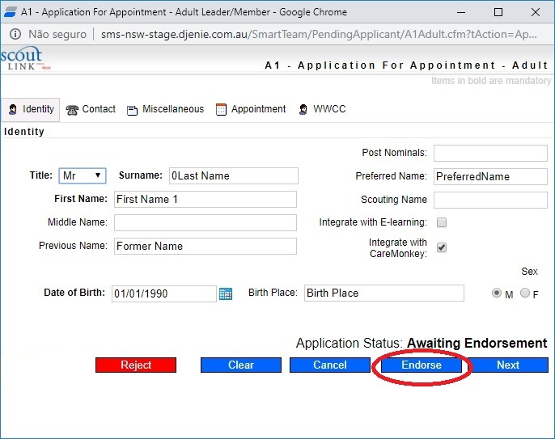

- Even after the original endorsement/formation approval, the applicant will still be listed as a “Pre-Applicant” in the “Pending Applications” list.

Endorse the formation approval

- Log into ScoutLink at https://scoutlink.nswscouts.com.au
- Click on the “ScoutLink” context menu on the left-hand side to expand further options

- Click on “Member” menu item.
- Click on the “Pending Applications” button highlighted in green.

- You can search the applicants by typing in the Keyword/s field. Using the * will perform a wildcard search.
- Alternatively, you can click on the “Application In” button on the applicant you wish to approve.

- Click on the “Accept” button under the default “Identity” tab to endorse the formation approval
- Alternatively, click on “Reject” to refuse the application

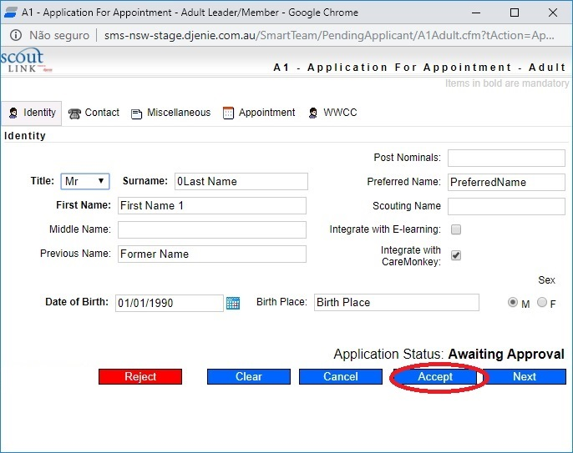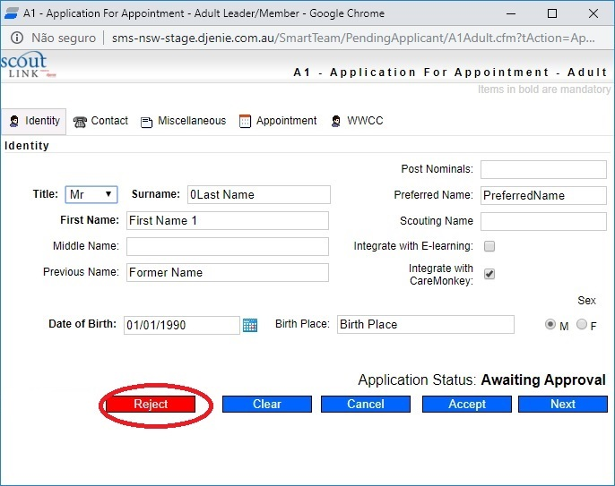

- The applicant will still be listed in the “Pending Applications” list

Updating the Working With Children Check (WWCC)

- Log into ScoutLink at https://scoutlink.nswscouts.com.au
- Click on the “ScoutLink” context menu on the left-hand side to expand further options

- Click on “Member” menu item.
- Click on the “Pending Applications” button highlighted in green.

- You can search the applicants by typing in the Keyword/s field. Using the * will perform a wildcard search.
- Alternatively, you can click on the “Application In” button on the applicant you wish to approve.

- Click on the “WWCC” tab.
- Click on the “Edit” icon next to the WWCC Application number

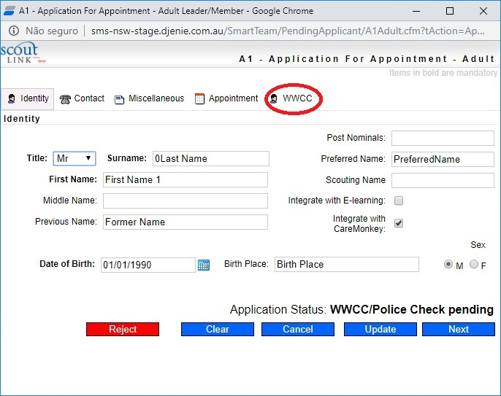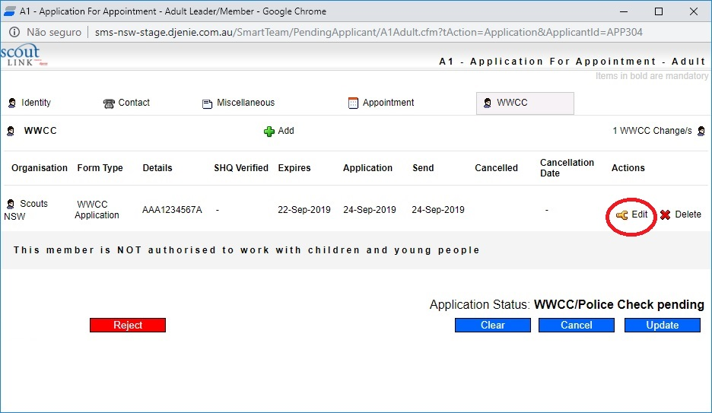

- For a WWCC that has been APPROVED, choose the “WWCC Confirmation” option under the “Form Type” field
- For a WWCC that has been REJECTED, choose the “WWCC Barred” option under the “Form Type” field

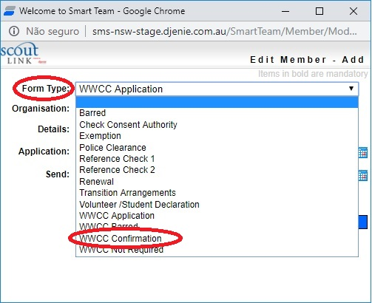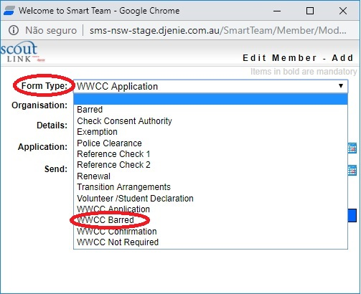

- Enter the Scouts HQ verification date next to the “SHQ Verified” field
- Click on the “Edit” button to save your changes
- For a FAILED WWCC, click the “Reject” button.
- For a SUCCESSFUL WWCC, click the “Update” button.

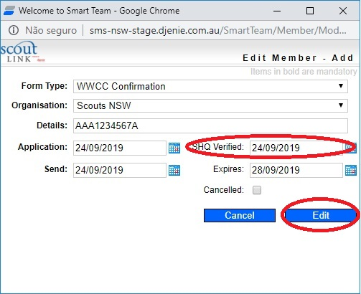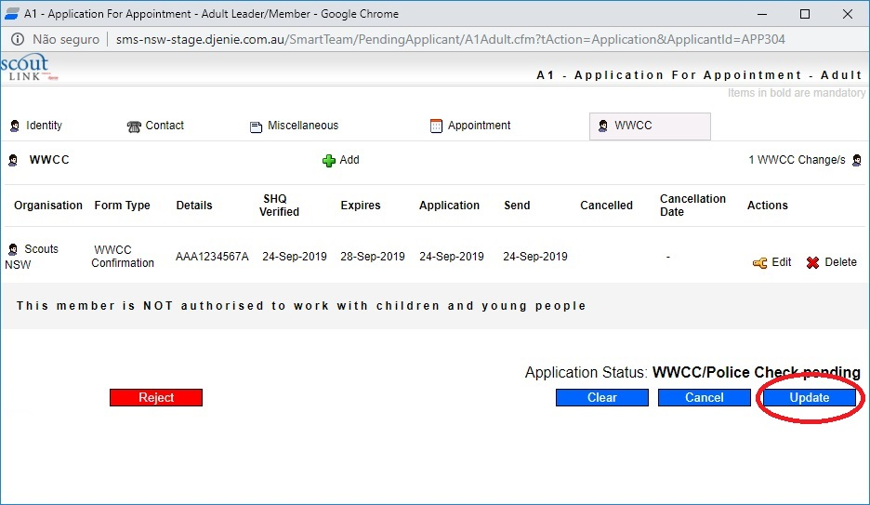

- The applicant will still be listed in the “Pending Applications” list

Updating the Police Check

- Log into ScoutLink at https://scoutlink.nswscouts.com.au
- Click on the “ScoutLink” context menu on the left-hand side to expand further options

- Click on “Member” menu item.
- Click on the “Pending Applications” button highlighted in green.

- You can search the applicants by typing in the Keyword/s field. Using the * will perform a wildcard search.
- Alternatively, you can click on the “Application In” button on the applicant you wish to approve.

- Click on the “WWCC” tab
- Click on the “+ADD” button

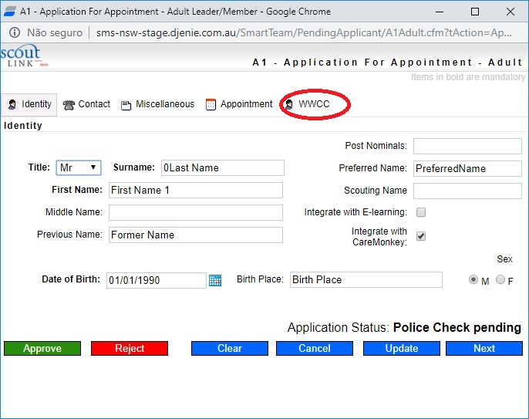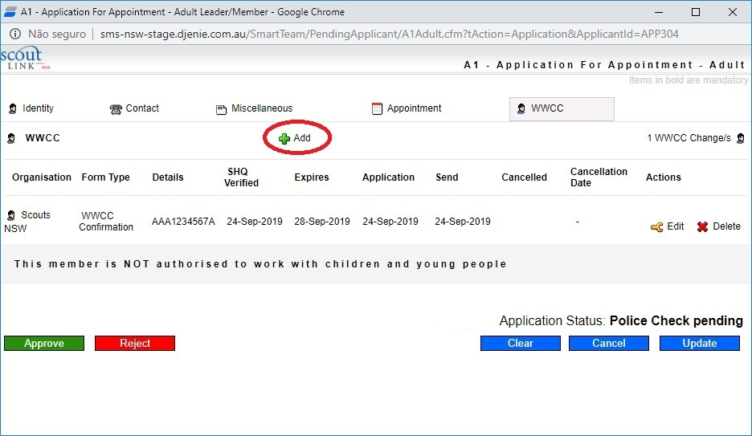

- Click on the “Form Type” field.
- Choose the “Police Clearance” option
- Set the “Organisation” field.
- Fill out the “Details” field.
- Set the “SHQ Verified” field to the date confirmation was received
- Set the “Expires” field with the clearance expiry date
- Click on the “Add” button
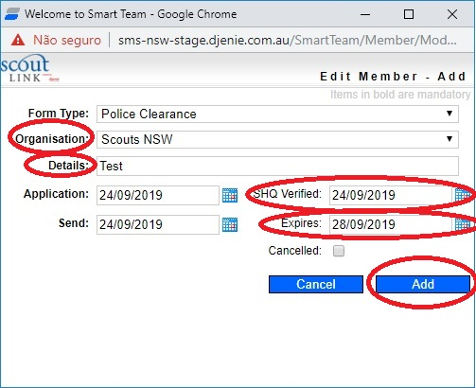
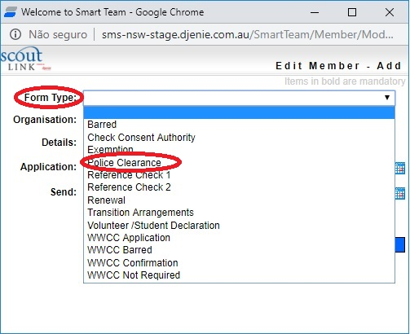

- If the Police Check was approved, click on the “Approve” button
- If the Police Check returns exceptions or results, click on “Reject”

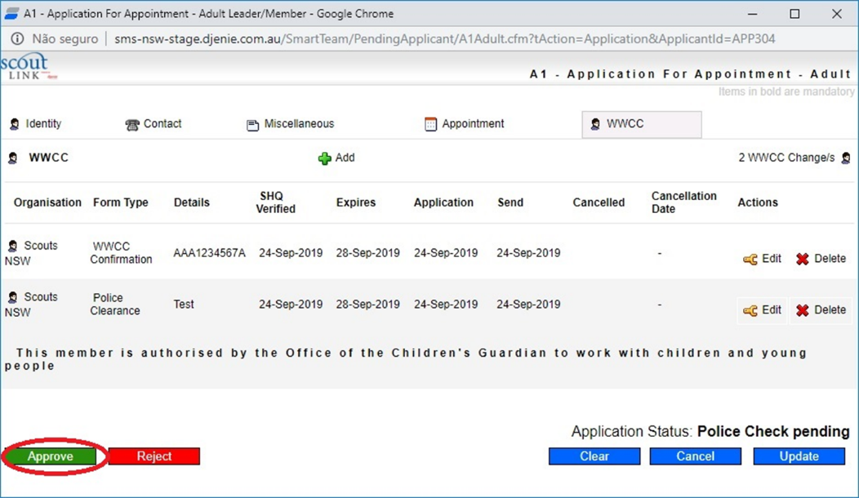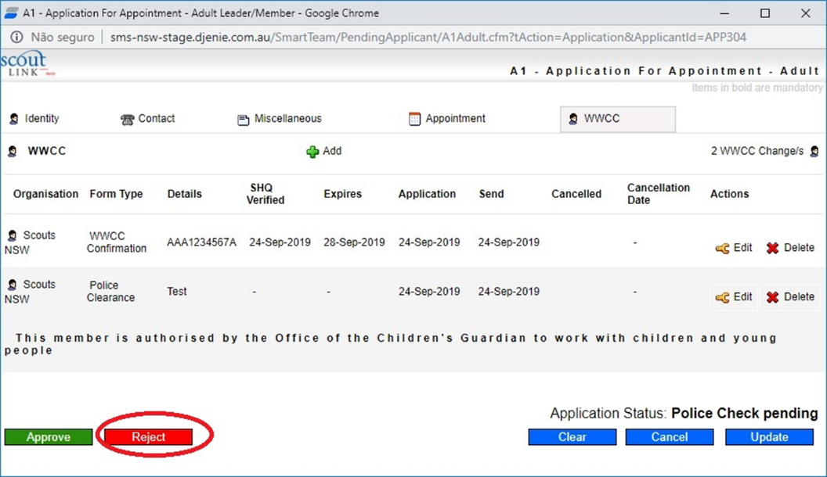

- If the Police Check is successful, the applicant will no longer be listed in the “Pending Applications” list.
- Click on “Back to Members Listing” button to see the new member records.

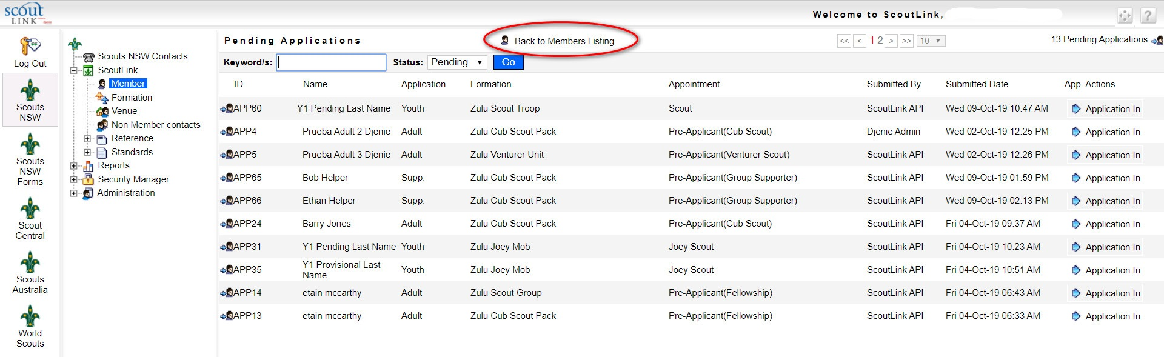

- The approved applicant will now be listed as “Current”.
