Information for Group Leaders/Leaders in Charge
Online adult helper application form (A2)

All new support committee members, adult helpers and adults who attend an overnight Scouting activity are required to complete an adult helper application form. Please note this includes parents/carers and guardians who attend any overnight Scouting activity. Scouts NSW has made this form available online via the Scouts NSW website.

Who needs to complete an adult helper application form (A2)?
All new support committee members, adult helpers and adults who attend an overnight Scouting activity are required to complete an adult helper application form. Please note this includes parents/carers and guardians who attend any overnight Scouting activity. The A2 form is now available online and should be used instead of the traditional paper-based A2 form.

Why is the form now online?
Scouts NSW has made this form available online to simplify the process for adult helpers to join Scouts NSW. The online A2 form also streamlines the endorsement process for Group Leaders and Regions, and eliminates the need for a paper-based form by integrating directly into ScoutLink.

The content of the A2 form has not changed.

Where is the online A2 form located?
The online A2 form can be accessed from the Scouts NSW website - https://www.nsw.scouts.com.au/adult-helper-application/

Is the paper-based A2 still available and accepted?
Paper-based forms are still available for now but will be withdrawn from availability in January 2020. Therefore, we recommend you begin using the online version of the A2 form as soon as possible. Paper-based forms will continue to be accepted and processed until 1 February 2020. After this time, all A2 applications will need to be completed using the online forms.

In some exceptionally rare circumstances, an applicant may need to access a paper-based A2 form after this date. In such cases, permission will be required from your Region Commissioner/District Commissioner and the paper form will be supplied and processed by the Region Office Manager.

What is the process for online A2 forms?
The process for the online adult helper application form as at 21 October 2019 is detailed below:

Step 1 | The adult helper fills in the online A2 form and the details are automatically entered into ScoutLink.
Step 2 | The Region Office Manager (ROM), Region Commissioner (RC) or District Commissioner (DC), and Group Leader (GL) or Leader in Charge (LIC) receive an email advising an application is waiting to be endorsed in ScoutLink by the GL/LIC.
Step 3 | The GL/LIC must log into ScoutLink to endorse the application. Before endorsing the application, the GL/LIC may conduct reference checks using the details provided by the applicant. (Reference checks are optional.)
Step 4 | The RC/DC receives an email advising there is an endorsed application in ScoutLink that is awaiting their approval. The RC/DC must then log into ScoutLink and approve or reject the application endorsement.
Step 5 | The ROM will receive an email confirming that the endorsement has been approved, and will then need to log into ScoutLink and validate the applicant’s Working With Children Check (WWCC).
Step 6 | The State Office receives an email advising that a Police Check is required. The State Office representative must log into ScoutLink to verify the Police Check. The adult member can now participate in Scout activities.

Note: If the WWCC or Police Check is not approved, the ROM or State Office must advise the Child Protection Team, which will determine whether the application can proceed. In many cases, the application will be allowed to continue. If applicants are resigned, an email will be sent to the ROM and RC/DC to advise them of this, and the application will not progress any further. In this case, the adult helper will not be allowed to participate in Scout activities.

What are my responsibilities as a Group Leader?
As a Group Leader/Leader in Charge, you simply need to:
- Monitor your emails for any new adult helper (A2) membership applications.
- Assess each application before approving or endorsing them in ScoutLink, including conducting reference checks if you wish.
- Ensure all adults attending overnight camps and activities have a current WWCC and have submitted an online A2 form. You must ensure you endorse these applications before the camp or activity commences.
- Notify your Region Office if there are any issues with an application.

What will the email notification look like?
The email notification will look like the message below:

How do I endorse an application for adult helpers?
- Log into ScoutLink at https://scoutlink.nswscouts.com.au
- Click on the ScoutLink context menu on the left-hand side to expand further options
- Click on Member menu item
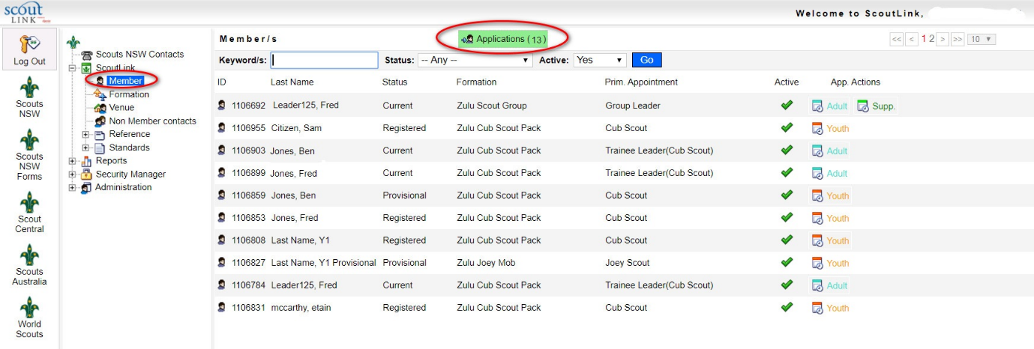
- Click on the green Applications button

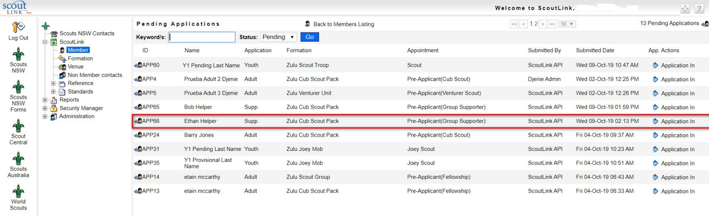
5. Click on the Application In button on the applicant you wish to process

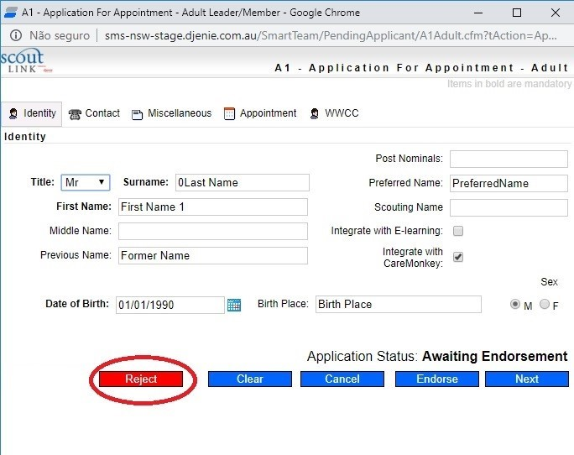
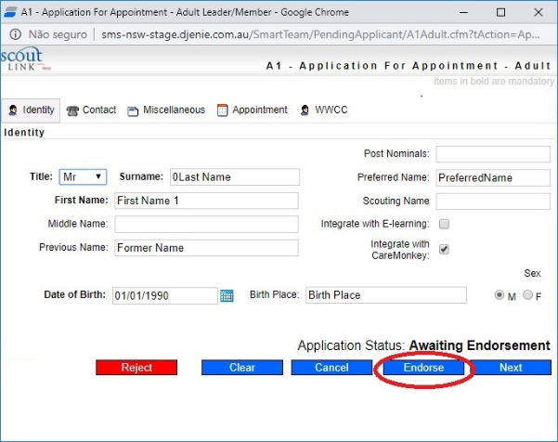
6. Click the Reject button to refuse the application or Endorse to approve the application (Note: in ScoutLink, the title of the form will be A1, even though the form being processed is an A2 form. This is due to how ScoutLink is configured and will not affect how the A2 form is processed.)

7. The applicant will still be listed as a Pre-Applicant in the Pending Applications list. An email will now be sent to the RC to advise them that they need to log into ScoutLink to approve or reject this endorsement.

Whom can I contact if I have a question about the A2 form?
For user questions, please contact Member Services at info@nsw.scouts.com.au. If you experience technical issues with the form, please contact the IT department at ITSupport@nsw.scouts.com.au

