Information for Group Leaders/Leaders in Charge
Online Youth Membership Application Form (Y1)

All new Youth Members are required to complete a Youth Membership application form (Y1). Scouts NSW has made this form available online via the Scouts NSW website.

Who needs to complete a Youth Member application form (Y1)?
All new youth member applicants who apply for membership with Scouts NSW must complete a Y1 form. The Y1 form is now available online should be used instead of the traditional paper-based Y1 form.

Why is the form now online?
Scouts NSW has made this form available online to simplify the process for a prospective youth member to join Scouts NSW. The online Y1 Form also streamlines the endorsement process for Group Leaders/Leaders in Charge and Regions and eliminates the need for a paper-based form. Through the online Y1 form process, youths applying to join Scouts will now be able to be supported and shepherded across their end-to-end joining Scouts journey.

The content of the Y1 form has not changed.

Where is the online Y1 form located?
The online Y1 form can be accessed from the Scouts NSW website - https://www.nsw.scouts.com.au/youth-membership-application/

Is the paper based Y1 form still available and accepted?
Paper-based forms are still available for now but will be withdrawn from availability in January 2020. Therefore, we recommend you begin using the online version of Y1 as soon as possible. Paper-based forms will continue to be accepted and processed until 1 February 2020. After this time, all Y1 applications will need to be completed using the online forms.
In some exceptionally rare circumstances, an applicant may need to access a paper-based Y1 form after this date. In such cases, permission will be required from your Region Commissioner and the paper form will be supplied and processed by the Region Office Manager.

What is the process for online Y1 applications?
The process for the online Youth Membership application form as at 14 October 2019 is detailed below:

Step 1 | The Youth Member applicant’s parent or primary carer completes the online Y1 form and the details are automatically entered into ScoutLink. The parents receive an email welcoming them to Scouts.
Step 2 | The Region Office Manager (ROM) and Group Leader (GL) or Leader in Charge (LIC) receive an email advising an application is waiting to be approved in ScoutLink by the GL/LIC.
Step 3 | The GL/LIC approves the application in ScoutLink, confirming the applicant is now a provisional (trial) member. This allocates the applicant a Scout membership number and generates an email to the parent/carer, which includes their membership number. The parent/carer will also receive a separate email inviting them to create a CareMonkey account for the youth applicant.
Step 4 | The applicant, ROM, and GL/LIC receive an email confirming that the applicant is now in provisional (trial) status, including the applicant’s Scout number. This email reminds the GL/LIC that, when the applicant’s trial period ends, which is dependent on the specific Group’s practice regarding length of trial periods, they should go into ScoutLink and endorse the applicant as a full member.
Step 5 | The applicant can now fully participate in all Scout activities as part of their trial period. This period may be as short as one week or as long as a maximum of three months, depending on your group’s needs.
Step 6 | When the applicant has completed their provisional (trial) period, the GL/LIC endorses their application in ScoutLink, at which point the applicant becomes a full member and the Group will be billed according to existing policies.

What are my responsibilities as a Group Leader/Leader in Charge?
As a Group Leader/Leader in Charge, you simply need to:
- Monitor your emails for any new Youth membership applications.
- Assess each application before approving or endorsing them in ScoutLink.
- Manage the applicant’s progress through the application, provisional (trial), and full membership stages of the youth joining Scouts journey.
- Notify your Region Office if there are any issues with an application.

If my Group is not on CareMonkey, does this mean our parents/carers cannot use the online Y1 form?
All parents/carers will be asked to use the online Y1 form. You will also need to provide an E1 form if your Group isn’t on CareMonkey. The E1 form can be accessed here.

What will the email notification look like?
The email notification will look like the message below.

How do I approve an applicant for provisional (trial) membership?
- Log into ScoutLink at https://scoutlink.nswscouts.com.au
- Click on the ScoutLink context menu on the left-hand side to expand further options
- Click on Member menu item
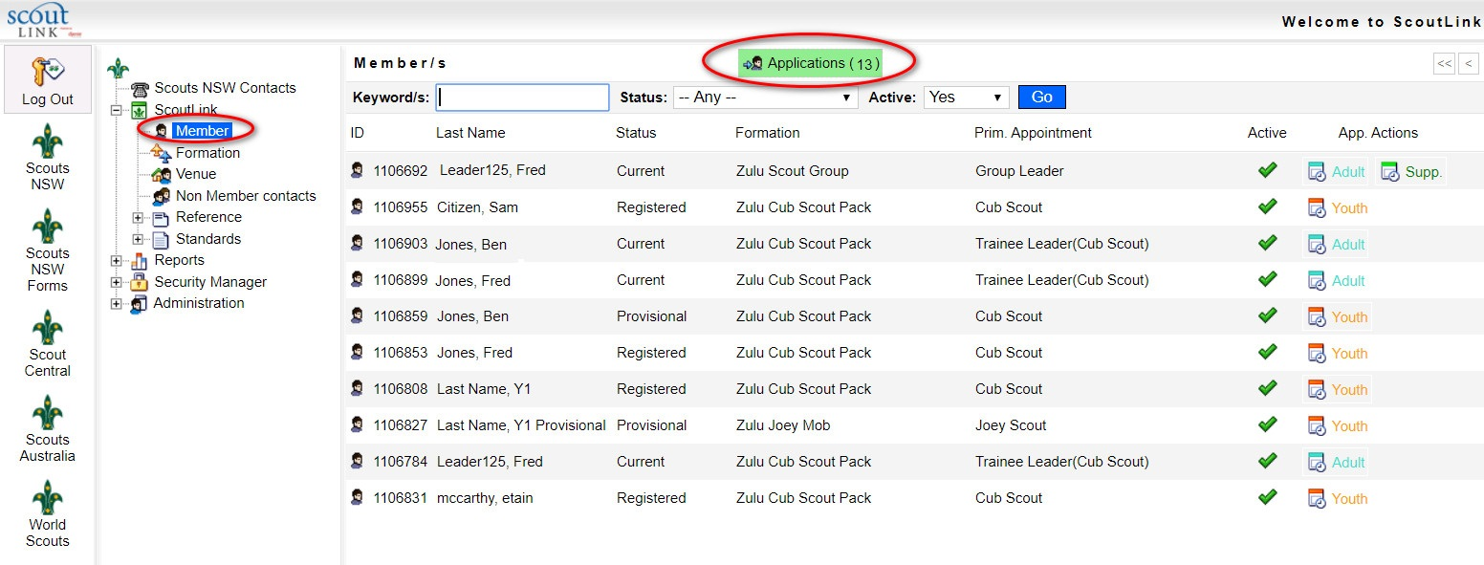
- Click on the Applications button highlighted in green.

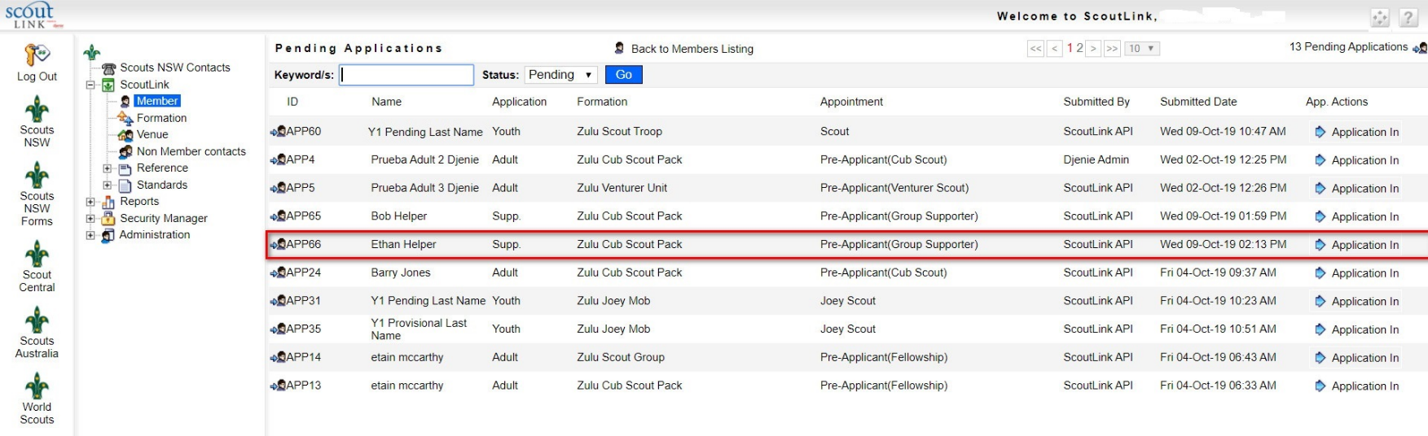
You can search the applicants by typing in the Keyword/s field. Using the * will perform a wildcard search. Alternatively, you can click on the Application In button on the applicant you wish to approve.

Click on the Approve button under the default Identity tab
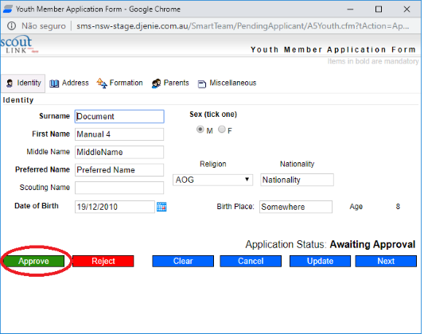

After approving the application, the applicant will no longer be listed in the Pending Applications list. The applicant will be listed as Provisional.

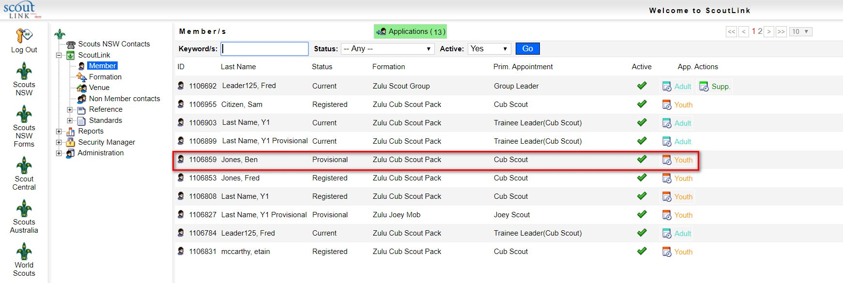
How do I approve an applicant for full membership?
Search the Provisional member’s record by typing in the Keyword/s field. Using the * will perform a wildcard search. Click on the applicant you wish to endorse.

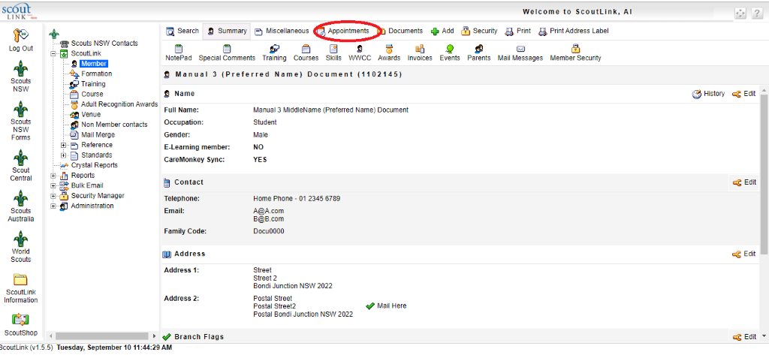
Click on the Appointments tab.

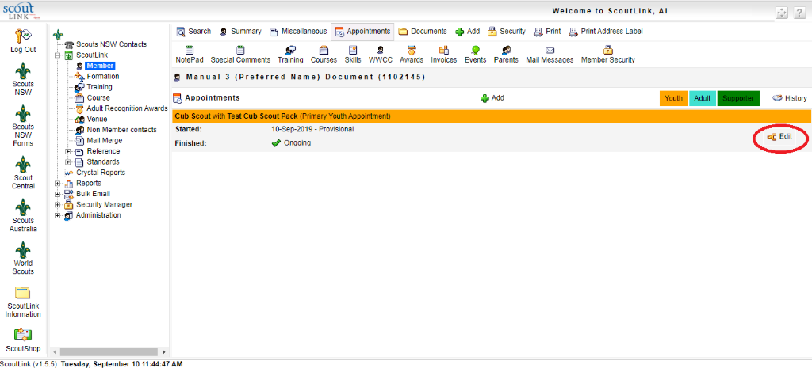
Locate the current appointment and confirm details. Then, click on the Edit icon next to the current appointment

Select the Youth Endorse option, then click the Update button to complete the process.
A new member’s appointment will be created as “Registered”
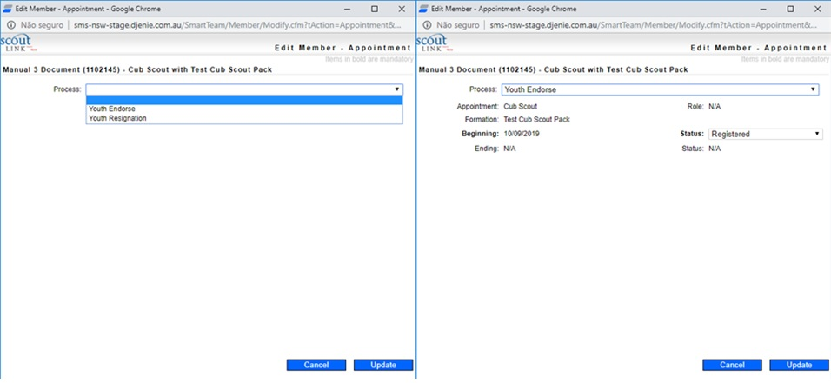

If you require further information, please contact the Scouts NSW Member Services Department on (02) 9735 9000 or info@nsw.scouts.com.au between the office hours of 9am and 5pm, Monday to Friday.

