Forms Automation
New Youth Process
V2
Contents

0 Version tracker 2
1 Main changes 3
2 Process overview 3
3 Rejecting an applicant 4
4 Approving an applicant 8
7 Membership status after approval 12
8 Endorse a provisional (trial) member 14
9 Membership status after endorsement 19
10 Resign a provisional (trial) member 20
11 Membership status after resignation 25

Version Tracker

Date | Version No# | Update Type | Author | Comments
22/09/2019 | 1.0 | Draft | Alexandre De Silva | First draft
2/10/2019 | 2.0 | Major | Jared Hale | Manual redesign, information and additional screenshots added
16/10/2019 | 2.1 | Minor | Sam Lenton | Proofing, updated screenshots added

Main changes
- New applicants are now automatically registered on ScoutLink.
- Group Leaders will be required to go to ScoutLink to approve the application.
- Applicants will be placed into a provisional (trial) status during their trial period until endorsed.
- A CareMonkey account will be automatically created and linked.
- Group Leaders will be responsible for endorsing the provisional (trial) applicant into a full member in ScoutLink.
- A provisional (trial) member will be automatically resigned if not endorsed by the Group Leader within three months.
- Periodic emails will remind the Group Leaders of any pending applications or upcoming trial period lapses.

Process overview
This process allows new prospective members to be automatically registered on ScoutLink without human intervention. This eliminates the need for paper forms and manual data entry of application information by the Group Leaders and Region Office Managers.

Further time is saved by automating the CareMonkey account creation process to track medical conditions, parental consent and other external services.
The invoice process will remain the same, however, provisional (trial) members are not included in the invoice run. Invoices are generated each quarter for every full registered member.
If there is no Group Leader appointed for a specific group, the notification email will be delivered to the Region Office Manager (ROM) instead.

Rejecting an applicant

- Log into ScoutLink at https://scoutlink.nswscouts.com.au
- Click on the “ScoutLink” context menu on the left-hand side to expand further options

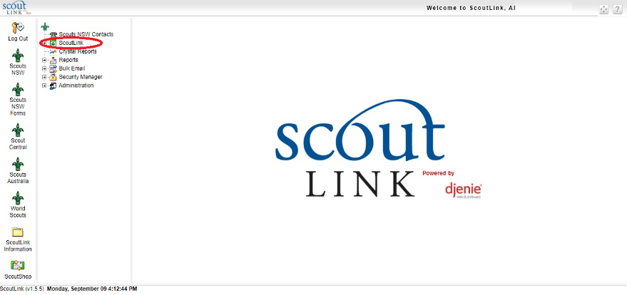

- Click on “Member” menu item.
- Click on the “Pending Applications” button highlighted in green.
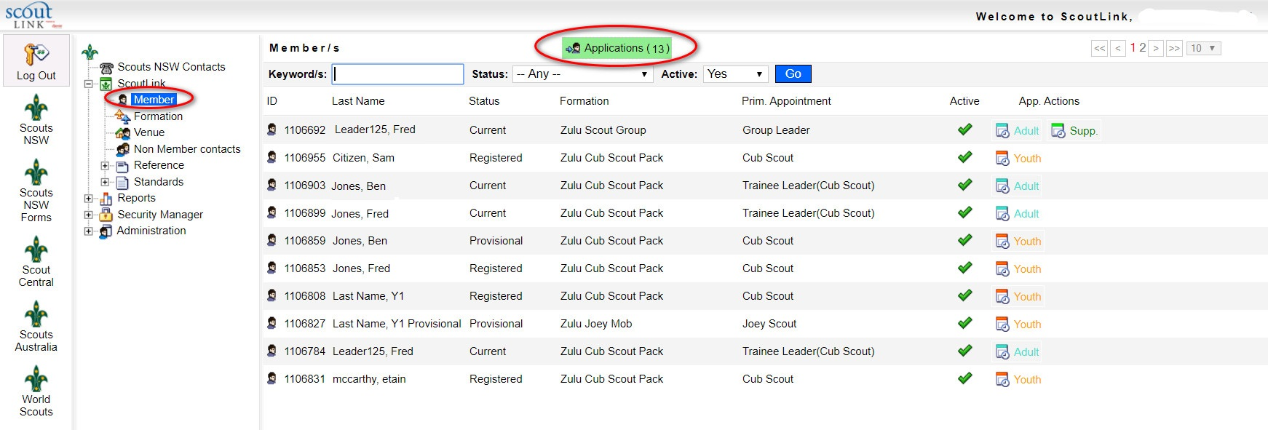

- Click on the “Application In” button on the applicant you wish to process

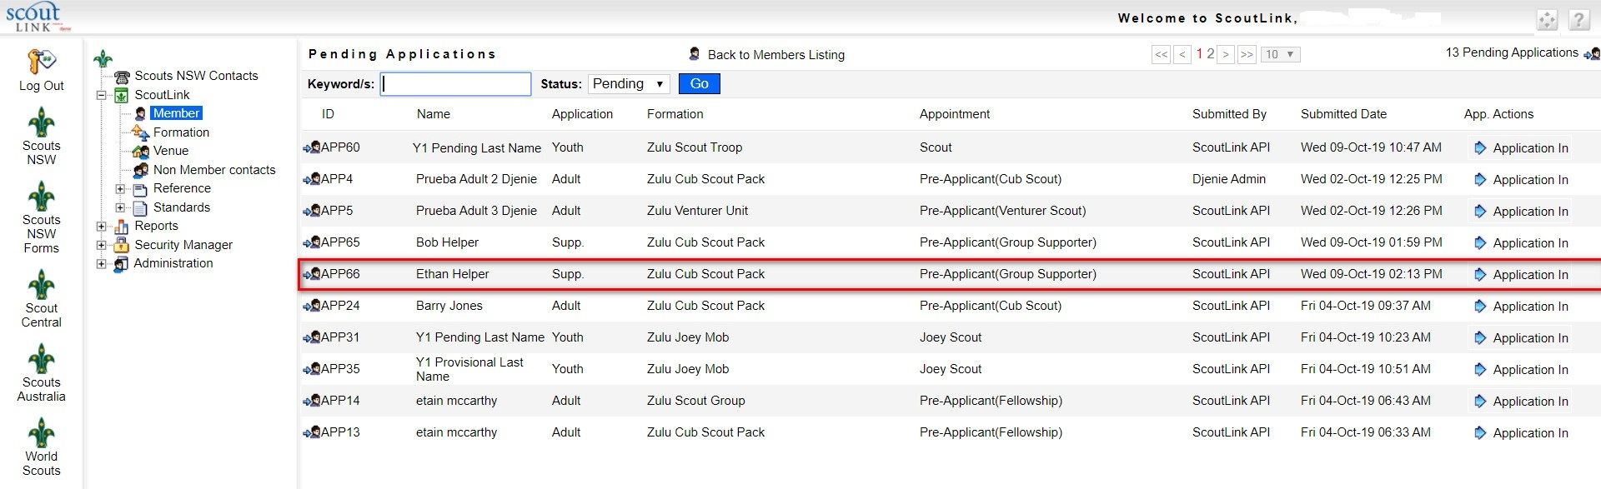

- Click on “Reject” button.
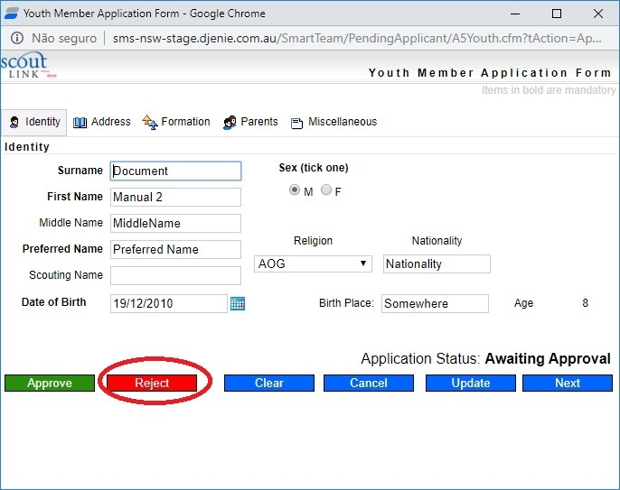

Approving an applicant

- Log into ScoutLink at https://scoutlink.nswscouts.com.au
- Click on the “ScoutLink” context menu on the left-hand side to expand further options

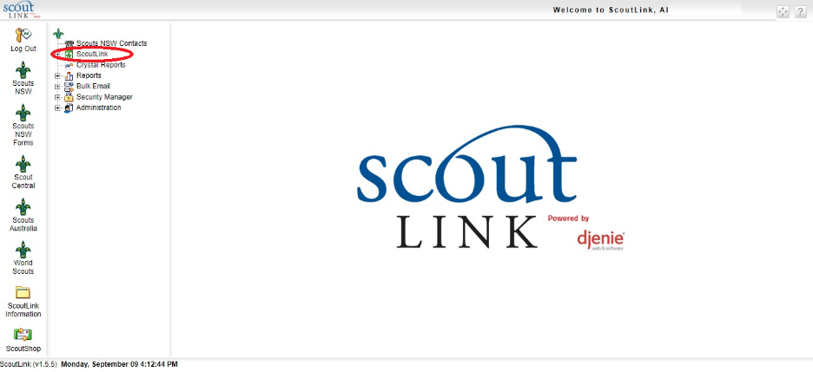

- Click on “Member” menu item.
- Click on the “Pending Applications” button highlighted in green.

- You can search the applicants by typing in the Keyword/s field. Using the * will perform a wildcard search.
- Alternatively, you can click on the “Application In” button on the applicant you wish to approve.

- Click on the “Approve” button under the default “Identity” tab

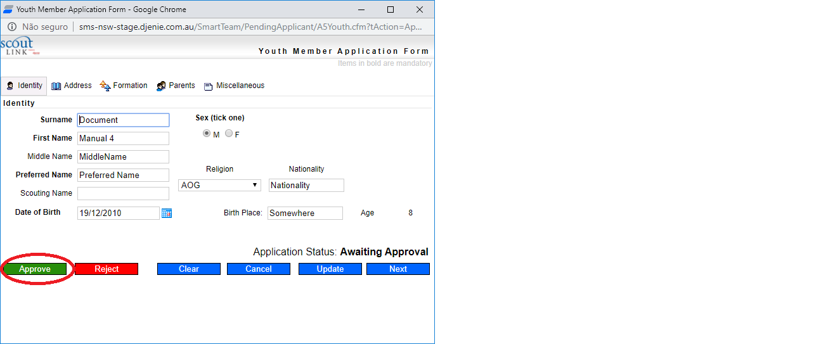

Membership status after approval

- After approving the application, the applicant will no longer be listed in the “Pending Applications” list.
- Click on the “Back to Members Listing” button to navigate to active members.
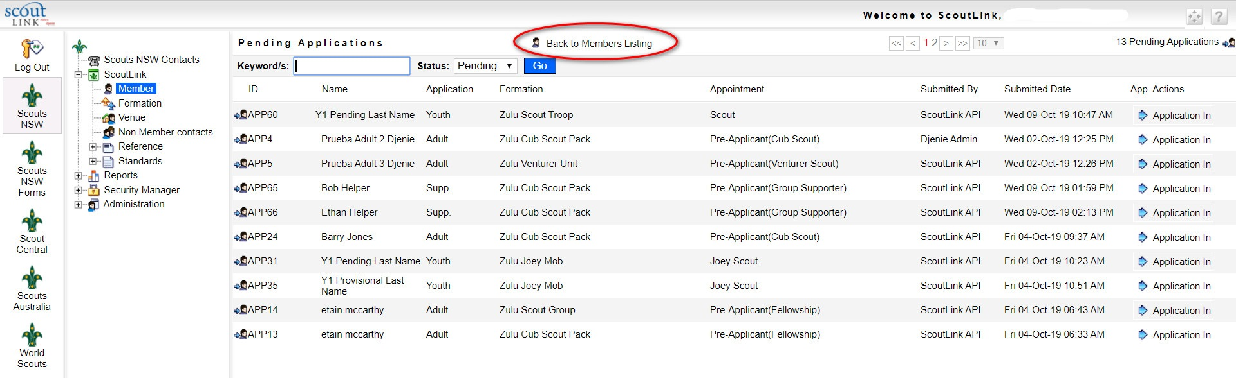

- The applicant will be listed as “Provisional”.

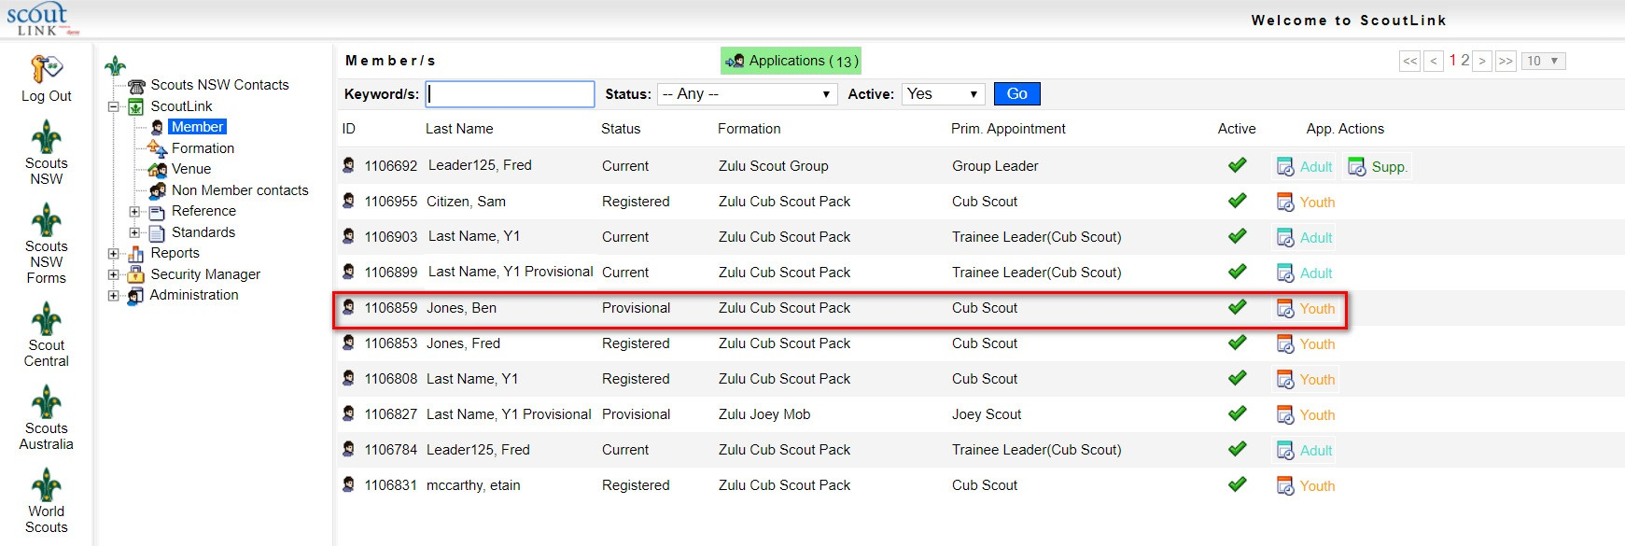

Endorse a provisional (trial) member

- Log into ScoutLink at https://scoutlink.nswscouts.com.au
- Click on the “ScoutLink” context menu on the left-hand side to expand further options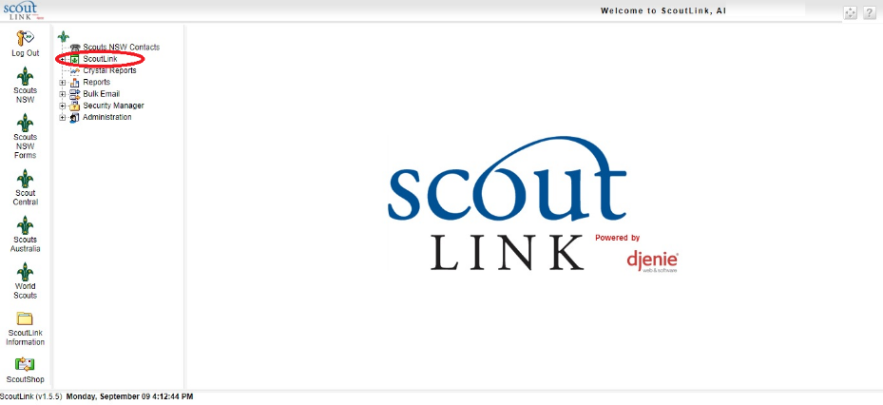

- Search the provisional (trial) member’s record by typing in the Keyword/s field. Using the * will perform a wildcard search.
- Confirm the member’s status is “Provisional”
- Click on the applicant you wish to endorse

- Click on “Appointments” tab

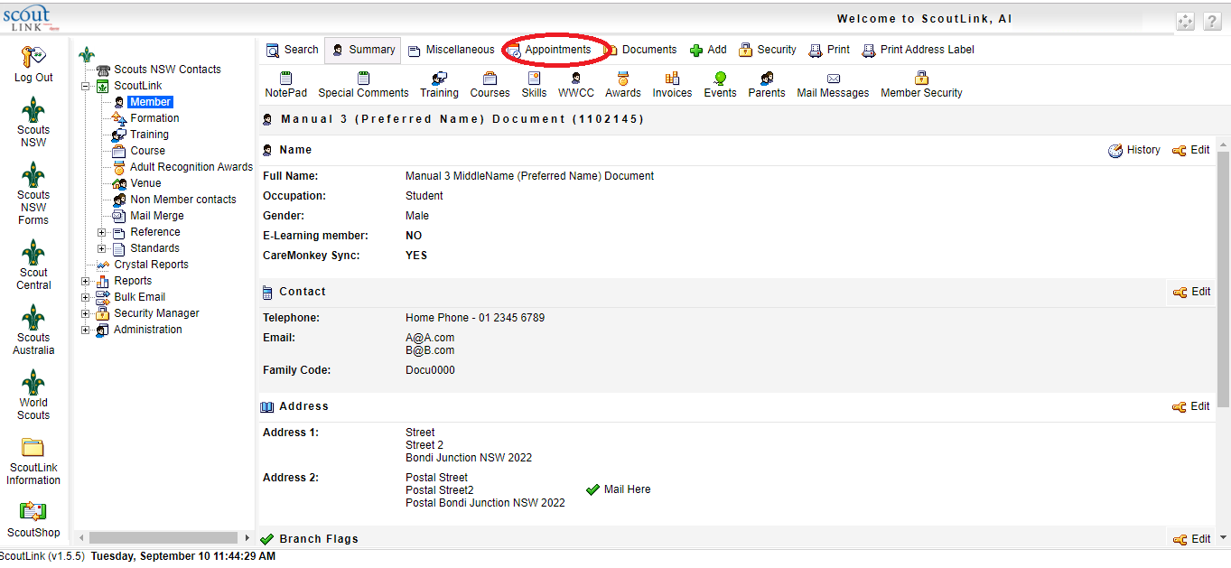

- Locate the current appointment and confirm details
- Click on the Edit icon next to the current appointment
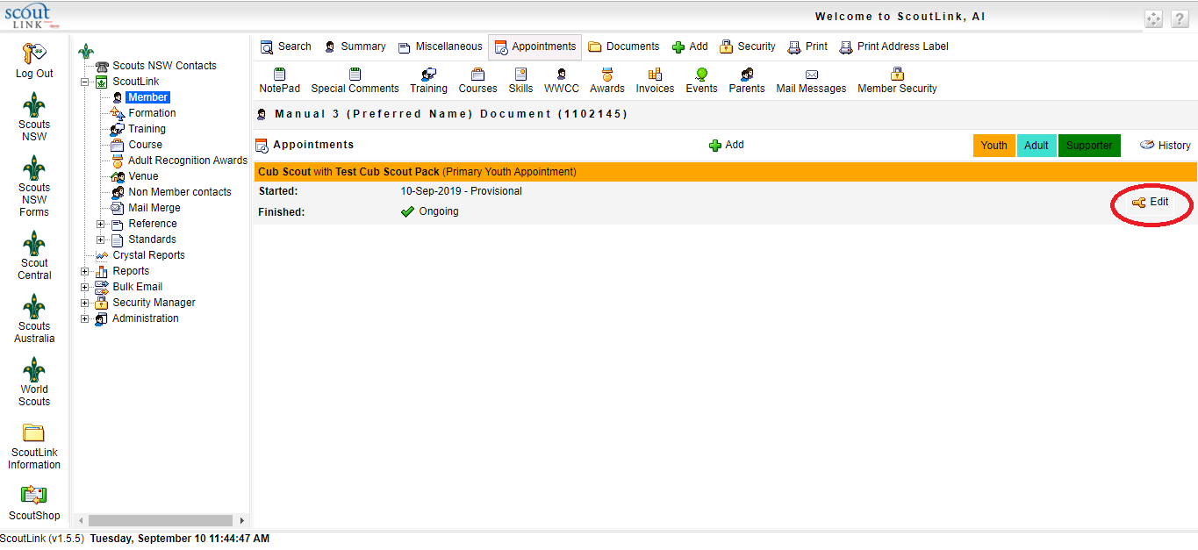

- Select the “Youth Endorse” option
- Click the “Update” button to complete
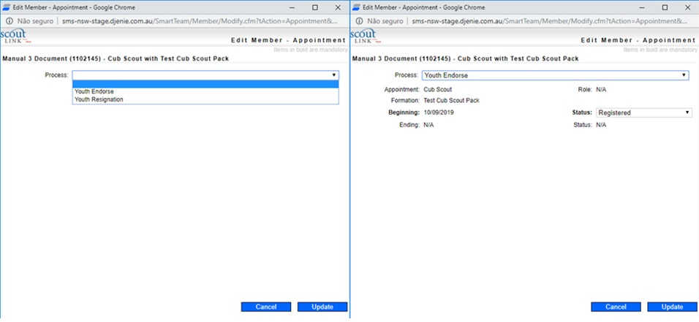

- A new member’s appointment will be created as “Registered”
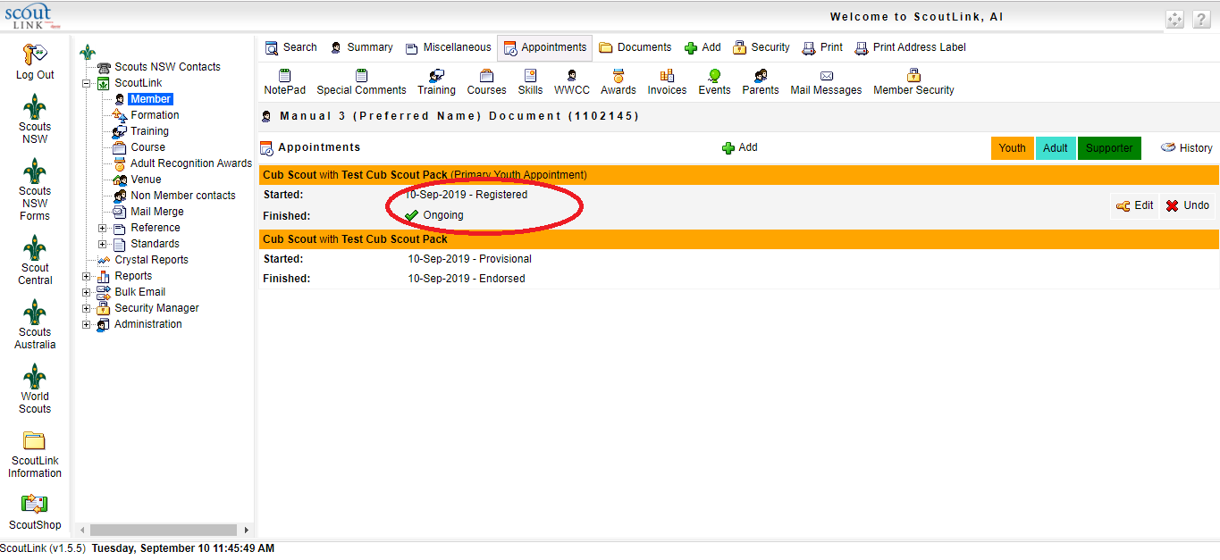

Resign a provisional (trial) member

- Log into ScoutLink at https://scoutlink.nswscouts.com.au
- Click on the “ScoutLink” context menu on the left-hand side to expand further options

- Search the member’s record by typing in the Keyword/s field. Using the * will perform a wildcard search.

- Click on the “Appointments” tab.

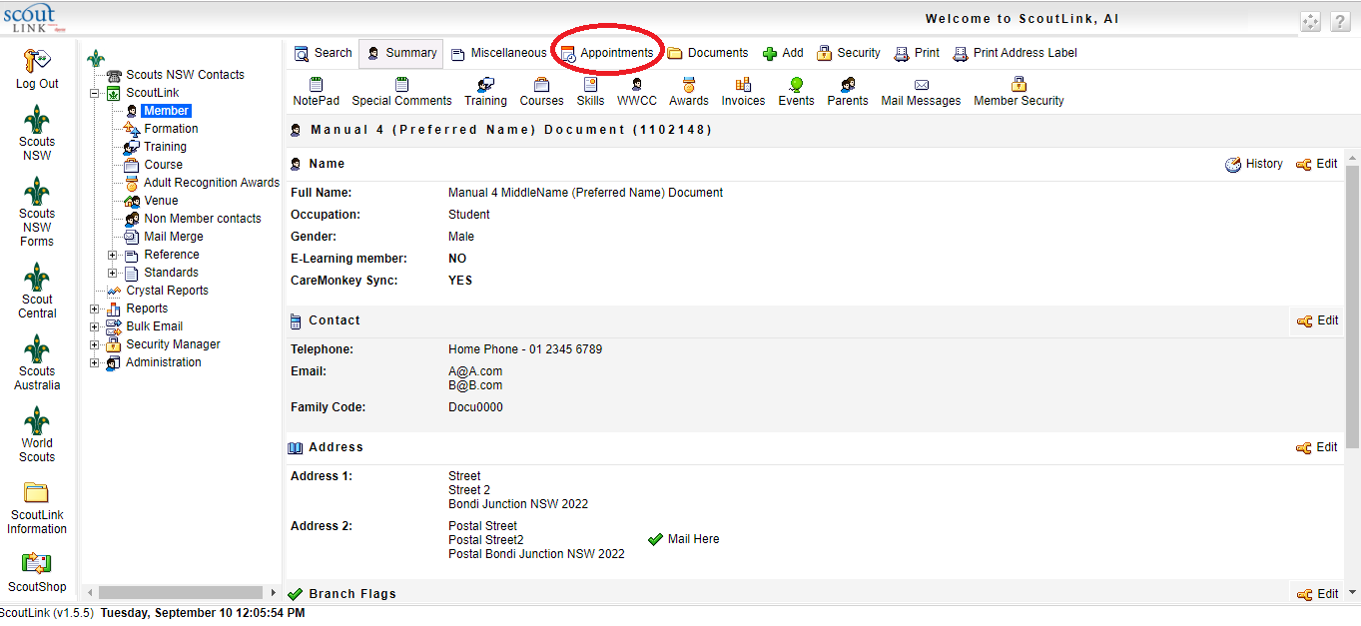

- Locate the current appointment and confirm details
- Click on the “Edit” icon next to the current appointment
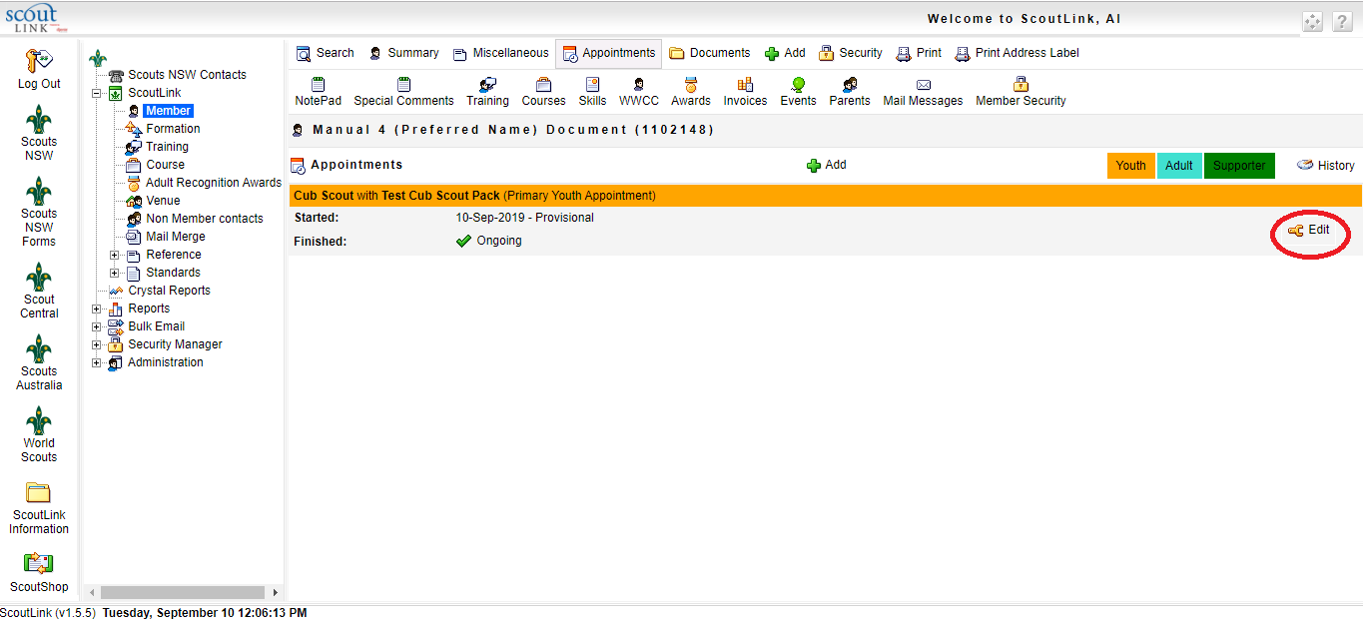

- Select the “Youth Resignation” option
- If the resignation date is different to the date this action is processed, you can edit the official resignation date in the “Ending” field.
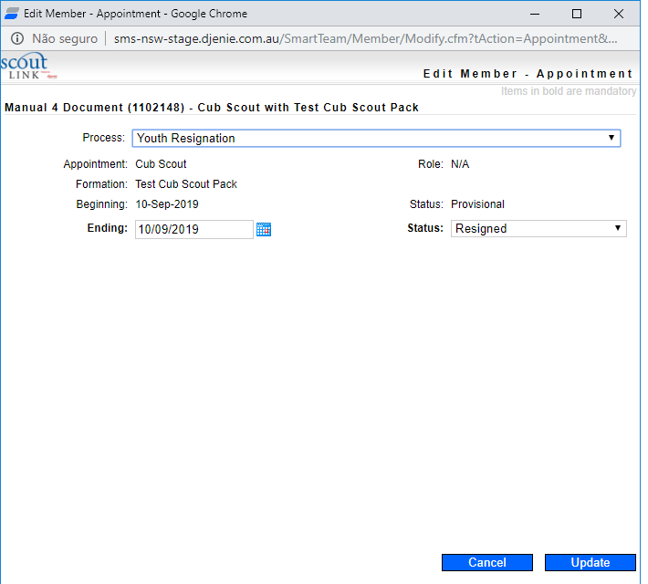
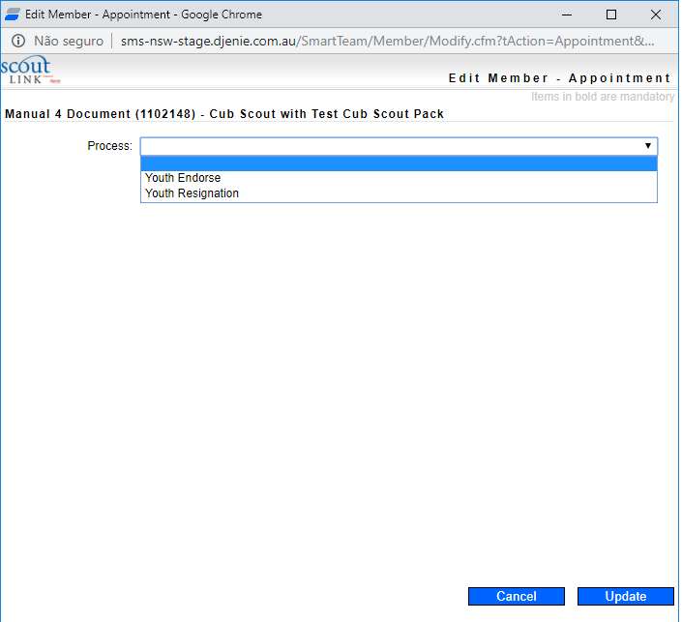
- Click the “Update” button to complete

Membership status after resignation

- Membership appointment will be displayed as “Resigned”

